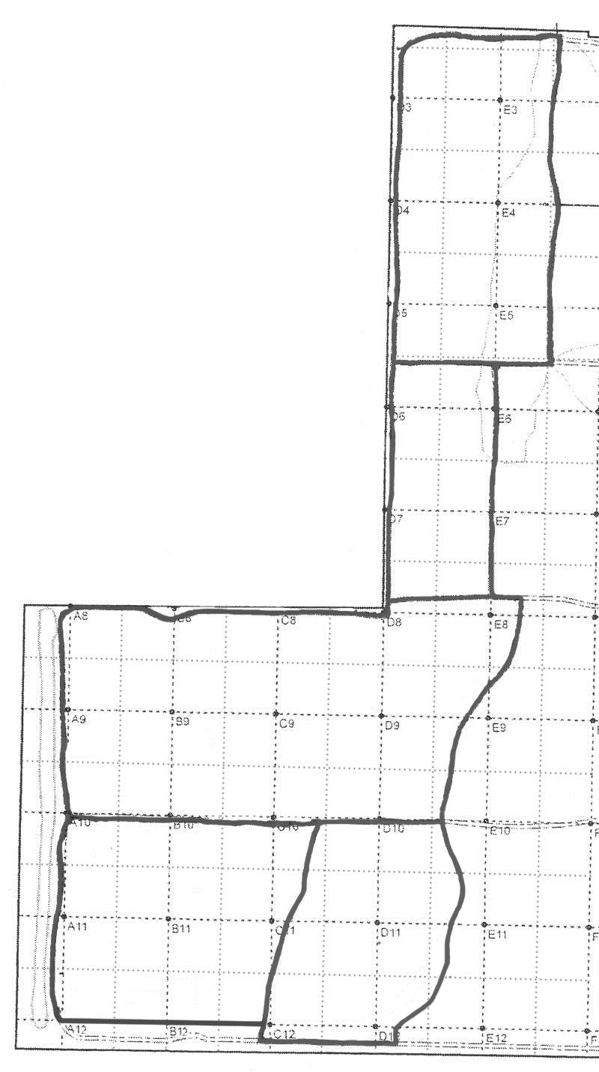

**Methods:**

* Estimate coverage in each whole or partial quarter gridblock to the nearest 10% unless too close to call (then use nearest 5%).
* Calculations are made with a [spreadsheet](http://natl.ifas.ufl.edu/docs/BurnCoverage2013-date.xlsx) (at http://natl.ifas.ufl.edu/docs/BurnCoverage2013-date.xlsx).

NATL UP Blocks ___________

Date of burn _____________

Burn master _____________

Date of coverage estimate ____________

Estimator ___________

Estimated coverage ____________

**Estimation of Controlled Burn Coverage**