Points of interest: Each station is marked with a white plastic stake with a RED band near the top and a letter keyed to the explanations that follow in this guide. All other stakes are either for the Advanced Trail Guide (available online and at the Hammock Trail Kiosk), or for research purposes.

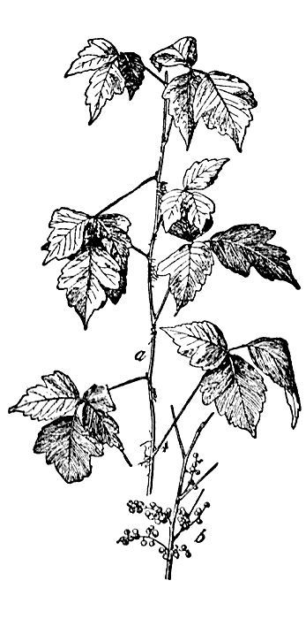
Poison Ivy Alert!
If you stray from the trail, you may encounter poison ivy (Rhus toxicodendron), as either a groundcover or vine. All parts of the plant have an oil that causes skin irritation in most people. It can be recognized by its spineless stem and leaves that are in groups of three.

What are hammocks?

In Florida, broadleaf forests are known as “hammocks.” Before the arrival of Europeans, the predominant forests in north Florida were pinelands that burned every 3 – 7 years. Hammocks were found on moist sites and areas protected from burning. Most present-day Florida hammocks were formerly forests of longleaf pine that were logged and then prevented from burning. Notice that there are no young pines in the hammock – without fire to kill broadleaf (hardwood) trees and shrubs, hardwoods outcompete pine seedlings and a hardwood hammock forest develops.

All images reprinted with permission of the University Press of Florida or from open-source material.
A Unrestored upland pine.

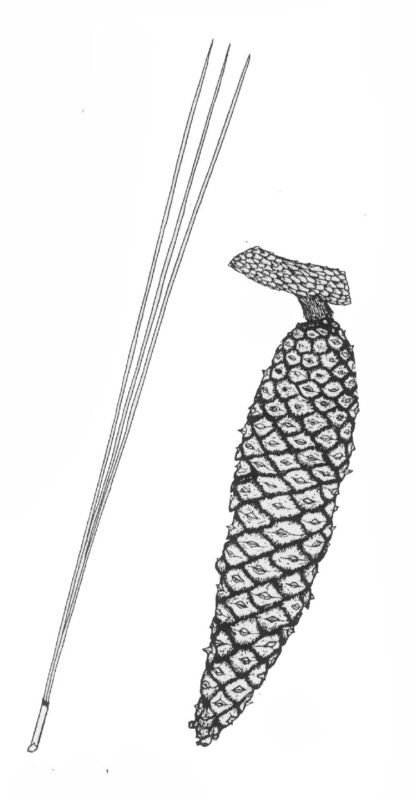
This area was once an upland pine forest but there has been no fire here since the state purchased the land in 1944. Hardwood trees have outcompeted young pines, and now only a few mature longleaf pines (Pinus palustris) remain of the former forest. You can recognize longleaf pine by their long needles and large spineless cones.

To learn more about upland pine, walk the Upland Pine Nature Trail.

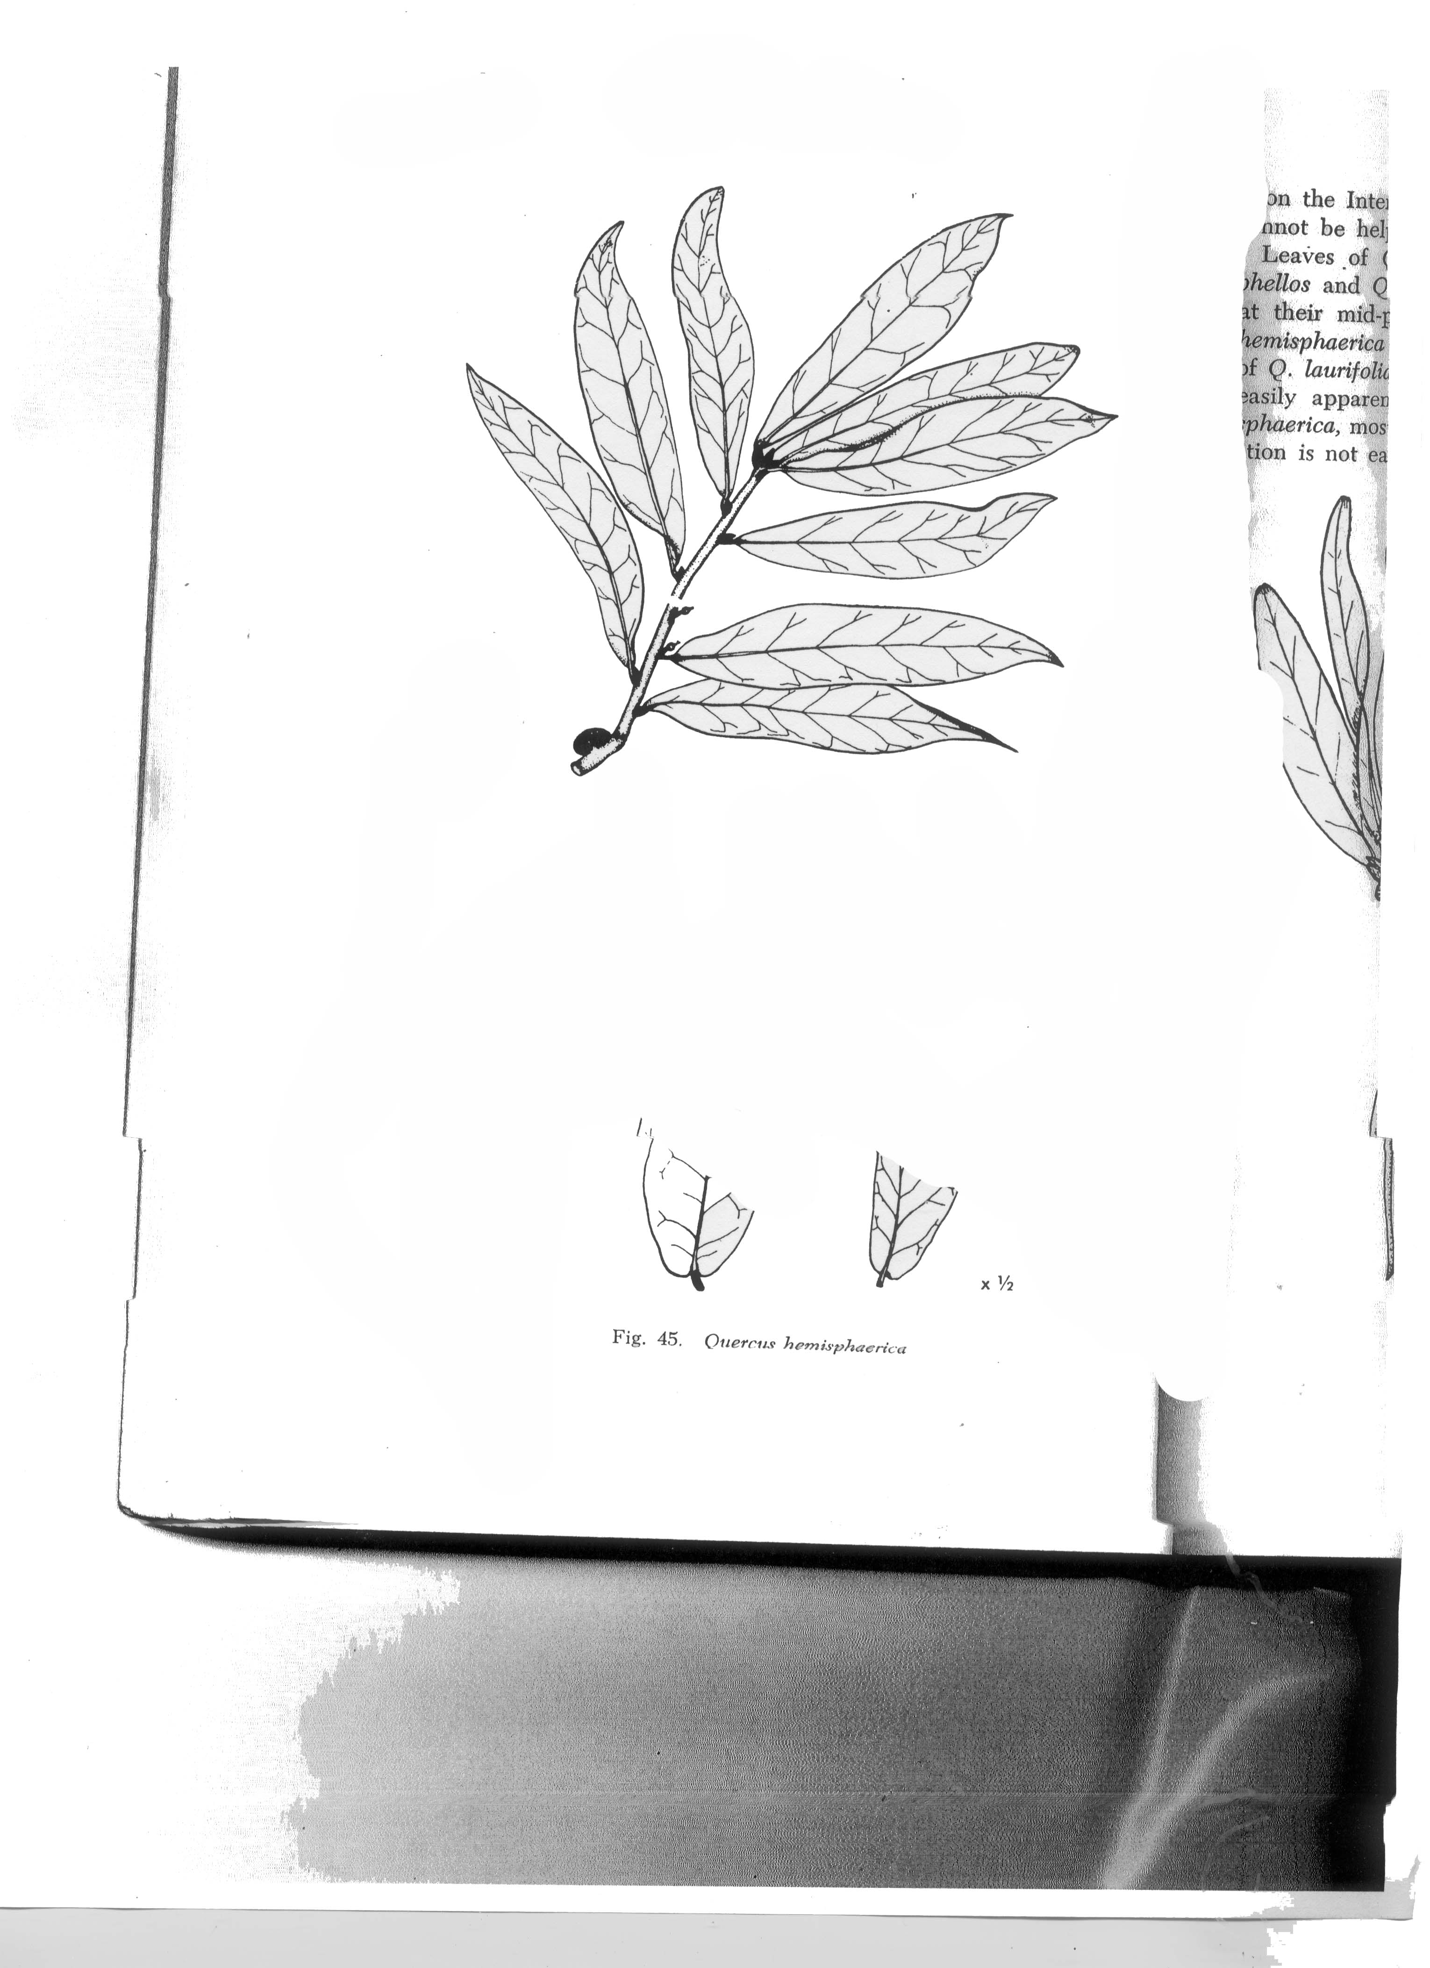
B Laurel oaks
Laurel oak (Quercus hemisphaerica) is a common hammock tree and will quickly invade longleaf pine forests when fire is prevented. It is planted as a shade tree because of its fast growth and dense foliage. However, its life span is only 60 – 80 years, and it is highly subject to rot and limb breakage. Laurel oaks have smooth narrow leaves that are shiny on both sides.

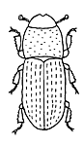
C Southern pine beetle attack!
The area where you are standing was once an abandoned field filled with even-aged loblolly pines. In 2001, southern pine beetles (Dendroctonus frontalis) killed most of the pines. The attacked trees had to be cut and hauled away to prevent the beetles from spreading. The stumps of two of these trees are marked with yellow flags.
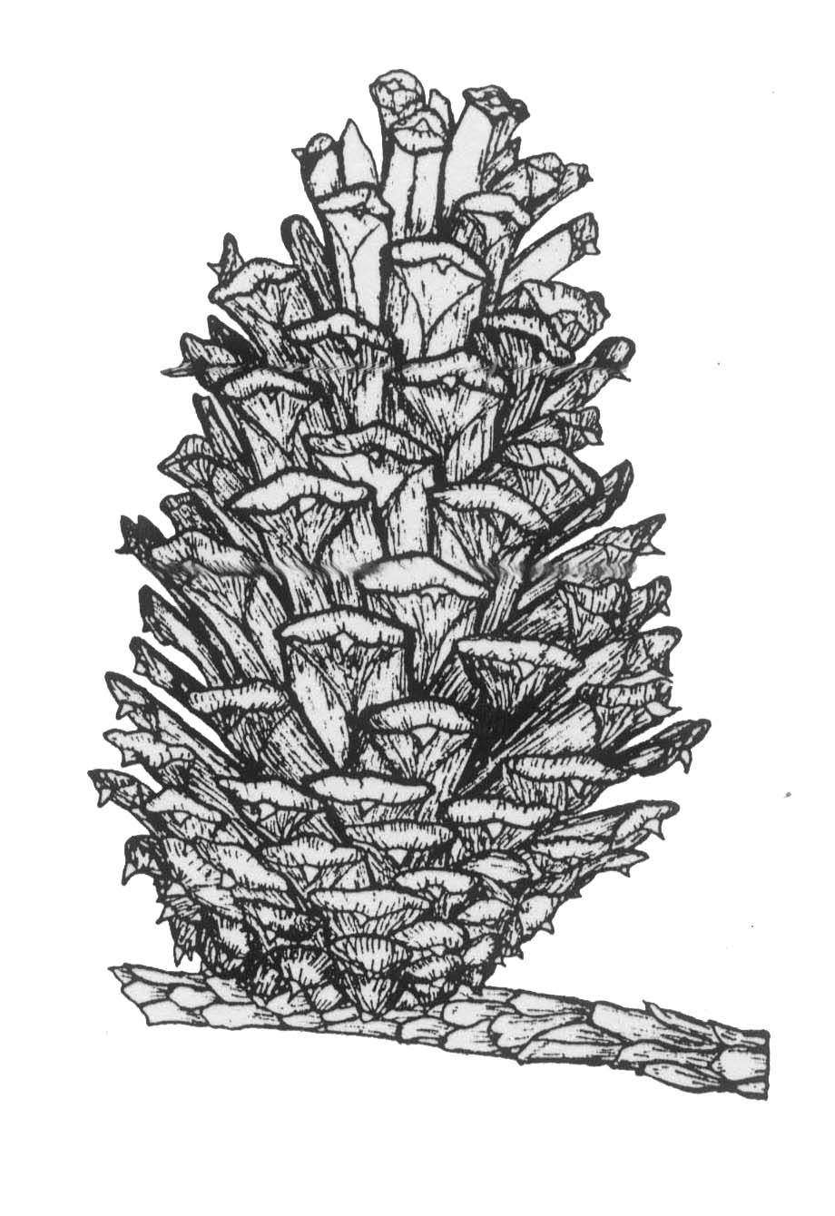
D Big loblolly.
This part of the trail passes through an area that in 1944 was a field with a few scattered loblolly pines. These pines are now approximately 100 years old, and the largest is about 35 feet north of here. This local giant is 36 inches in diameter at breast height. See if you can find a loblolly cone – squeeze it to feel the sharp spines!

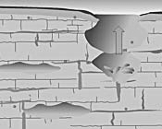
E Sink.
The Gainesville area is underlain by limestone that is riddled with caverns. When the roof of a cavern collapses, the soil above subsides and produces a sink as seen here.

F Devil’s walkingstick
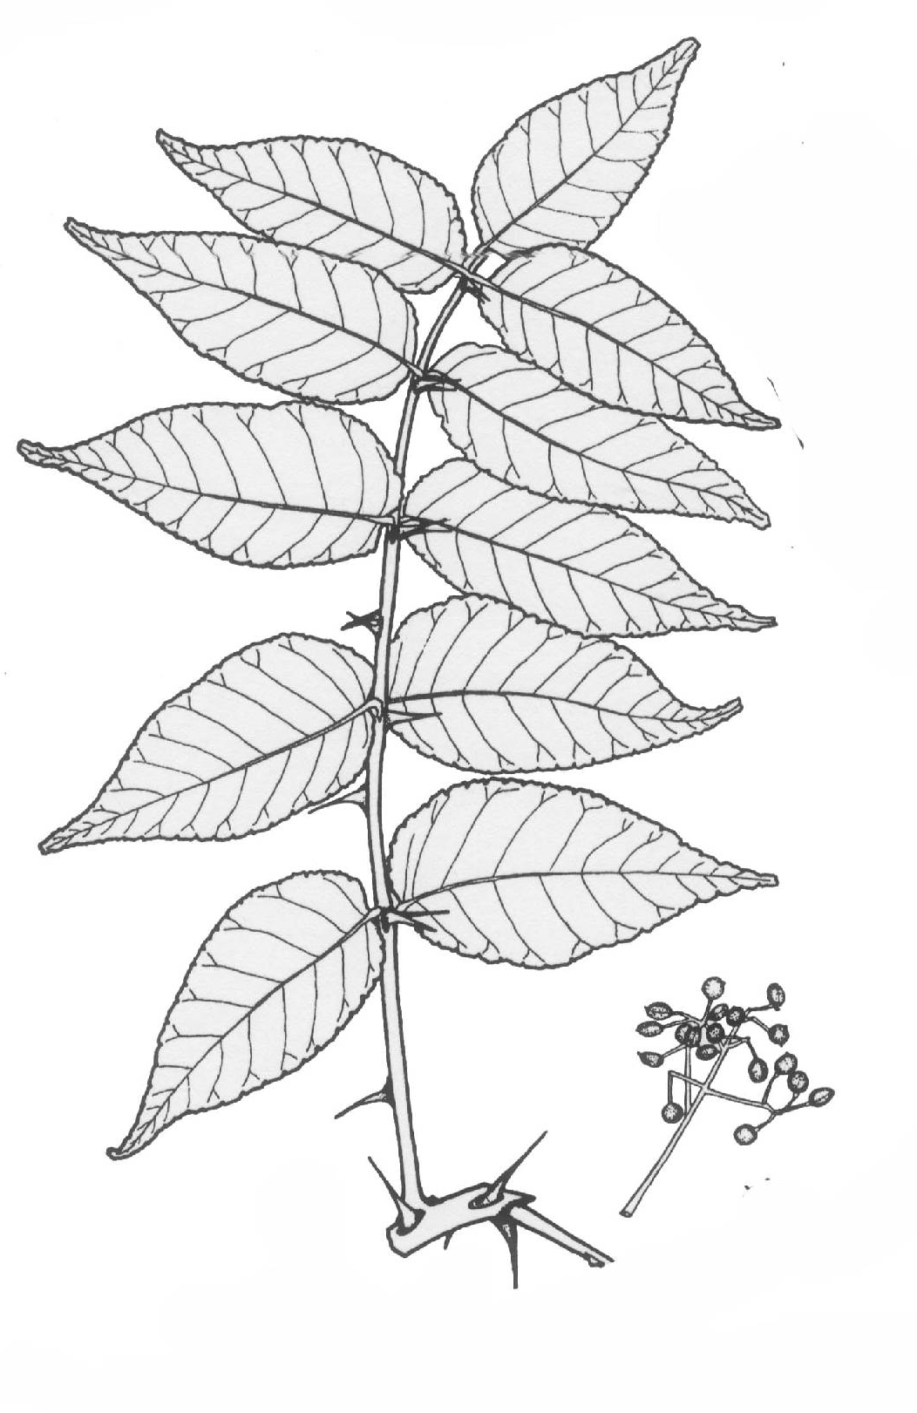
This small tree has a trunk you do not want to grab! Devil’s walking stick (Aralia spinosa) even has prickles on the leaves. This species spreads by underground runners and produces small thickets, such as the one here.

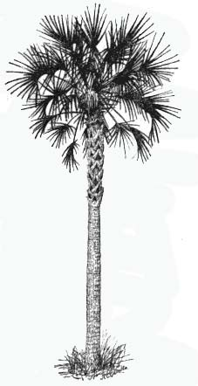
G Cabbage palm
When Florida’s state tree (Sabel palmetto) reaches about this height, its trunk usually sheds the rough bases of broken-off dead fronds that have clung to it for years.

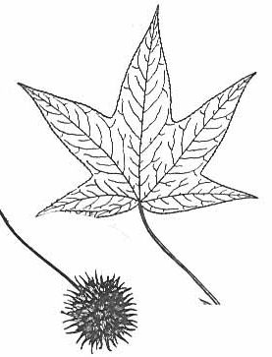
H Sweetgum
TRAILS
1 SEEP Wetland
2 Upland Pine
3 Old Field
4 Hammock

0 500 1000 ft
Picnic area
⁴
¹
²
K
K
K
K
K
K
K
K
Pavilion
³
Cultural Plaza
Natural Area Drive
Trail Map
Sweetgum trees (Liquidambar styraciflua) are easily recognized by their star-shaped leaves and round spiny fruit capsules. Crush a leaf and smell the aromatic compounds. Along with loblolly pine and black cherry, sweetgum is another pioneer species that rapidly invades abandoned fields in north Florida.

To learn more about plants in abandoned fields, walk the Old-Field Nature Trail.
Natural Area Teaching Lab

The University of Florida Natural Area Teaching Laboratory (NATL) is a 60-acre tract of land dedicated to teaching students and the public about ecology and biotic diversity.

Basic and advanced trail guides to Hammock, Upland Pine, and Old Field trails are available at entrance kiosks to each ecosystem (see map). A trail with interpretive signs circles the 3-acre SEEP Wetlands, an ecologically engineered stormwater retention basin.

For more information about NATL, including species lists, historical photos, soil maps and student projects, please visit http://natl.ifas.ufl.edu.
Basic trail guide to the

HAMMOCK Nature Trail
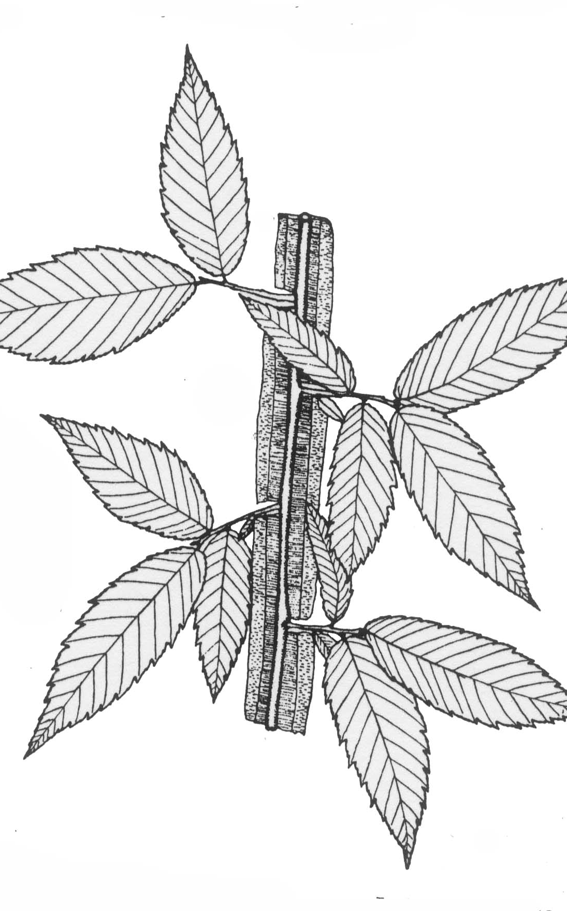

Winged Elm (Ulmus alata)

Natural Area Teaching Lab


K
Nature trail
Connecting trail
Informational Kiosk

