**Spring 2016 Meeting of the Natural Area Advisory Committee**

14 April 2016, NATL Academic Pavilion, 12:07-1:27pm

**In attendance:**

Morgan Byron (NATL Graduate TA)

Ross Danson (NATL Burn Coordinator)

Jennifer Gillett-Kaufman (Entomology and Nematology)

Gail Hansen de Chapman (Lakes, Vegetation, and Landscaping Committee)

Jessica Hong (NATL Invasive Species Intern)

Laura Harmon (NATL Wildlife Ecology and Conservation Intern)

Alex LoCastro (NATL Undergraduate TA)

Matt Moore (Entomology and Nematology Student Organization)

Lary Reeves (NATL Vice Chair)

Sean Sharp (Wetlands Club)

Erick Smith (Friend of NATL)

Matthew Smith (Plant Pathology)

Thomas Walker (Friend of NATL)

Emma Weeks (NATL Chair)

**12:07 PM**

**Introductions (Emma)**

Emma began the meeting by thanking all NAAC members for coming. Everyone introduced themselves, greeting the three new members of the NATL Operations Committee, Jessica (Jesh) Hong, the NATL Invasive Species Intern, Laura Harmon, the NATL Wildlife Ecology and Conservation Intern, and Ross Danson, NATL Burn Coordinator.

**1. Budget FY 2016 update- fiscal report on adherence to and/or deviation from 2015-2016 spending plan (Appendix 1) (Lary)**

Originally, the wrong fiscal sheet was included in the Agenda sent out to the NAAC prior to the meeting, so Lary passed around a copy of the correct version – the approved fiscal plan for 2015-2016. Lary explained that the money usually allocated to a second graduate teaching assistantship was allocated to pay for three OPS employees – an invasive species intern, wildlife intern, and a burn coordinator. Overall, NATL has been on track for 2015-2016 spending to date, with the largest expenditure thus far being the prescribed burn of all Upland Pine plots over Spring Break. The Upland Pine Restoration portion of the proposed 2016-2017 plan was thus increased, as the Operations Committee would like to burn the entire ecosystem once a year. Emma explained that in the past, only a portion of the Upland Pine area was burned at a time, with two burns scheduled per year. The new plan is to burn only once a year, employing Tom Workman. For this purpose, there was a surplus of funds used for the burn this year, but it is possible that in the future, NATL fundraising will be required to provide the additional money. Jennifer Gillett-Kaufman inquired as to whether the burn of all Upland Pine blocks was required each year, or if it could be done every other year if funds are not available. Ross Danson explained the need for a yearly fire regime to expedite restoration efforts. Lary also added that burning all blocks in one go is likely to provide better burn coverage for each block. Emma concluded that Blocks C, D, and E are in the greatest need of restoration efforts and if they were in the same shape as Blocks A and B, perhaps burning could go on every other year. Emma was also confident that NATL could find the additional funds needed each year, either through money left over in the miscellaneous expenses budget (proposed by Lary) or fundraising efforts.

**2. Preliminary draft of 2016-2017 spending plan for approval at Fall meeting (Appendix 2) (Lary)**

Tom Walker moved to approve this budget now, and his motion was seconded by Jennifer Gillett-Kaufman.

**3. Updates on possible capital improvements and funding sources (Appendix 3)**

The user survey carried out by Emma and TA, Morgan Byron, last October asked NATL users about changes or improvements they would like to see. The feedback from this survey altered the priorities for long range NATL wish list items, with lots of interest going towards enhancing the NATL pavilion – specifically providing lockers and teaching tools, like a projector screen.

Lockers were obtained from surplus and will be installed at the NATL pavilion soon. Emma also explained that three new tables for the pavilion were recently purchased and a whiteboard/projection screen will be erected at the back of the pavilion. The whiteboard project will be funded by CALS and carried out by PPD. NATL is also getting a water fountain and spigot, which will be installed by PPD using water redirected from a nearby building. Jennifer Gillett-Kaufman inquired if there would be a sink and drainboard in addition to the water fountain and spigot, but Emma said there were no plans for a sink, currently.

Regarding the lockers, Gail Hansen de Chapman wanted clarification on whether visitors would provide their own locks. Emma responded that users of the lockers will need to provide their own locks and that the TAs will be responsible for making sure there are no items left overnight in the lockers. Signs will be posted to reflect this rule. Alex LoCastro suggested that NATL purchase some locks to be checked out at the front desk in the Entomology and Nematology Department and this idea seemed generally well-received.

Emma asked Sean Sharp, the Wetlands Club representative, about the bench on the SEEP nature trail and inquired whether it would be possible to install another bench to complement the new Wetlands Bingo sign. This sign was designed by a group of Master Naturalists and will be installed along the boardwalk soon. Sean agreed to bring the question to the attention of the Wetlands Club.

Emma also described the virtual tours currently being developed by undergraduate TA, Alex LoCastro, as part of an ecotourism internship. He is creating walk-through videos of the trails using a mounted GoPro camera and hopes to have more in-depth, narrated tours for each trail finished by the end of Summer 2016.

**4. Wildlife Cameras**

Emma discussed the ongoing difficulty Morgan and Lary have been experiencing trying to get the SEEP nature viewing camera to be accessible on the web. Currently, the live feed is available on the NATL website but is viewable only to those connected to the UF network. They are working with UF IT to rectify this situation.

NATL Wildlife Ecology and Conservation Intern, Laura Harmon, has been using different kinds of cameras to track wildlife in NATL. She has been using a scope to look down into burrows found throughout NATL and has recorded both gopher tortoise and armadillo activity. Laura also set up a wildlife motion camera in NATL east, which has recorded raccoons.

**5. People Counter Summer (Appendix 4)**

Alex described the process by which NATL counts its visitors. There have been some technical difficulties with the TrailMaster devices, but lack of data has been accounted for by averaging the counts from previous years. He also mentioned the increase in users of the Cultural Plaza entrance in 2015 may be due to the installation of the boardwalk leading to that area.

**6. Volunteer Summary (Appendix 5)**

Morgan explained the graph and table shown in Appendix 5 that depict volunteer activity in NATL based on planned events. Regular volunteers Tom Walker, Hector Lacera, and Sara Alvarez also significantly added to the total of hours volunteered in NATL. Gail Hansen de Chapman wondered about the types of volunteers coming to the volunteer events – whether they were members of the community or mostly students. Morgan explained it was largely UF students, but that anyone is welcome to help and these events are widely advertised on NATL’s social media accounts. Matt Moore, ENSO President, suggested the NATL Operations Committee reach out to scout groups or campers for help with projects because they have been amenable to entomology-related events in the past.

**7. Minigrant update and 2016 planning**

Morgan gave an update on each of the NATL minigrant projects approved by the NAAC in November 2015. Both projects, described below, are still in the beginning stages:

1. “Do eastern newts prefer Cuban food?” is a project proposed by Allan Gonzalez and Celine Carneiro, both undergraduate students in the Wildlife Ecology and Conservation Department. Their faculty sponsor for the project is Dr. Steven Johnson, also from WEC. This project is aimed at investigating whether eastern newts will preferentially feed on Cuban tree frog tadpoles compared with the tadpoles of native frog species. This will hopefully shed light on possible population control attempts for this invasive species. This project will begin once all permits are in order.

2. In February, a late minigrant application was accepted and approved. This project was proposed by Andrew Nisip, an Entomology undergraduate working with Dr. Andrea Lucky, this project’s faculty sponsor. This project will involve an ant survey of NATL, resulting in an updated ant species list for the Biota section of the NATL website and an informative sign focusing on the top ten ant species in NATL to be placed along one of the trails. Andrew has begun sampling, using light-trapping at night and analyzing leaf litter samples.

**8. Social media updates**

NATL’s Facebook page has 1,051 Likes and the Twitter page has 1,013 Followers. Since the last NAAC meeting in September, we have gained 103 Facebook Likes and 173 followers on Twitter! The NATL Instagram account, created in June 2015, has 254 followers; that is over twice the number of followers since the Fall NAAC meeting!

If you use social media, please follow NATL on [Facebook](http://www.facebook.com/NATL.UF), [Twitter](https://twitter.com/UFNATL), and [Instagram](https://instagram.com/natl.uf/). The NATL TAs make an effort to post several times a week about what is going on in NATL. We also love posting about visitors using NATL, so please share any pictures or observations with us on any of these social media accounts.

**9. Control of invasive exotic plants in NATL (Appendix 6)**

Jesh Hong, NATL Invasive Species Intern, trained with Ethan Carter, former NATL Graduate TA and Invasive Species Intern, before his departure in December 2015. She has since gotten her herbicide applicator license and is keeping up with Ethan’s records of species of concern in NATL. So far, she has been focusing mostly on coral ardisia and camphor trees, as evidenced in the spreadsheet found in Appendix 6. The reduction in coral ardisia juvenile plants is due, in part, to volunteer events focused on manual removal. Jesh also explained the increase in young camphor trees, reporting that they were produced by a large, girdled camphor that has been in decline for the last four years. In the near future, Jesh plans to pursue her herbicide license focusing on aquatic plants, so she may tackle the parrot feather (*Myriophyllum aquaticum*) in NATL-east.

**10. Nature trail update, boardwalk concerns (Alex)**

Alex spoke about how he, along with regular volunteers, Hector and Sara, routinely trim the nature trails to a height of 80 inches to be compliant with the Americans with Disabilities Act (ADA). He is also responsible for mowing the trails and updating the photosigns.

Last month, the northeast portion of Old-Field Plot B was successfully restarted. The southwest portion of Plot B is set to be restarted this fall. Since the last meeting, preparations for the 2020 restart of Old-Field Plot E have begun. This entails the mechanical removal of hardwood species from the plot and an herbicidal application to their stumps. In August, preparations for the 2017 restart of Plot D will begin.

As of February 2016, Mark Clark and the Wetlands Club have completed replacing all of the boards damaged by the flooding last summer. Erick Smith suggested the NATL Operations Committee look into using composite lumber or plastic boards to replace those damaged by flooding. Sean Sharp suggested he contact Mark Clark about this, for future planning.

**11. Restoration of Upland Pine (Appendix 7)**

*Recent and future management of upland pine*.

Ross, the NATL Burn Coordinator spoke about the recent burn of the Upland Pine ecosystem and his job of managing the burn of a relatively urban site, in which many people must be kept in the loop. He relayed that Tom Workman managed a controlled burn for the entire Upland Pine area on March 2, 2016. In blocks A and B, the public area Upland Pine, burn coverage was estimated at 100%. In blocks C, D, and E, the restricted area Upland Pine, burn coverage was estimated at 95%, 85%, and 85%, respectively.

Ross went on to explain the details of a NATL improvement approved at the last meeting, involving Upland Pine demonstrations plots. The purpose of these is to help involve the UF Forestry department in the use and potential management of this area, according to Emma. Early this year, members of the NATL staff outlined a demonstration area to contrast two Upland Pine restoration treatments: mechanical (mowing) and chemical (herbicide). The demonstration area is 50 meters wide and 200 meters long, situated on the western end of the restricted area (see map in Appendix 7). Half of this area is designated to demonstrate an herbicide treatment, and the other half of the area is designated to demonstrate a mowing treatment. To contrast these two treatments to the more traditional treatment of prescribed burning, the demonstration area was isolated from the prescribed burn in March 2016. In late March the mowing treatment was completed. The herbicide treatment will be completed in April. Just as the prescribed burn occurs annually, the mowing and herbicide treatment will be implemented annually.

**12. NATL Campus Visibility**

Emma told the NAAC about the recent success the Operations Committee has had increasing NATL’s visibility among new and existing students and faculty. Alex LoCastro completed a volunteer factsheet with information about how to get to NATL and what to bring. Morgan Byron represented NATL at the UF Office of Sustainability’s Biodiversity Symposium with a poster about how NATL is a source of biodiversity on campus. NATL website renovation, including an interactive map component, is planned for the coming semester – as Morgan will be learning more about website development through a Summer internship.

**Wetlands Club update (Sean Sharp)**

Sean Sharp distributed a map of the SEEP with proposed areas of vegetation removal indicated by Mark Clark. The major goal of this is to promote more herbaceous growth than the woody growth that is currently beginning to dominate the ecosystem. Trees have already been marked for removal with orange flagging. As an added benefit, removal of woody plant growth will hopefully open up the SEEP for better wildlife viewing. Sean also suggested in his plans adjustments to the SEEP trail along Old-field Plot B, where the trail is starting to slope down into the plot itself. Gail Hansen de Chapman stated that trees to be removed for restoration purposes need not be approved by the LVL, likewise trees under 3 inches in diameter do not need approval from the LVL prior to removal. NAAC will be kept informed on further information about this SEEP renovation. Emma has requested that Sean send a proposal to her for distribution to the NAAC by email as this discussion was at the end of the meeting when few members remained.

**ENSO update (Matt Moore)**

Matt asked Emma if students checking out the light trapping equipment from the front desk in the Entomology and Nematology Department were asking for NATL permission first. Emma said they usually were not and that this was not required. Permission may become required in the future to prevent damage to the kit, although no problems have been reported.

**Next NAAC meeting date and time**

The date and time of **Noon, September 15, 2016** was suggested in the agenda. If you know of a conflict, please let Emma know as soon as you can.

**1:27 PM Meeting Adjourns**

**Appendix 1: Fiscal Report for FY 2015-16**



**Appendix 2: Fiscal Plan for 2016-17**



**Appendix 3: Capital Improvements Updated Fall 2015 Report**

The following items were discussed and compiled by the NATL Operations Committee and modified based on a week’s discussion by NAAC members. Some items have an associated web link that is an example of the item described.

**Long Range NATL Wish List: 2011-2021 Vision Plan**

We recognize that NATL already has tremendous value to the local UF community. This Vision Plan seeks to strengthen and enhance these indigenous values of NATL and, in addition, provide mechanisms for bringing the educational values of NATL to an unlimited online environmental community of users. We present the plan in the form of a two-part outline of infrastructure and other developments, focusing on both in-person and online users of NATL.

This list is not static; additional items may be added to the list. Items will be removed from the list if more than half of the NAAC members feel that the item would not enhance the use of NATL.Funding for items could come from donations to the UFF on behalf of NATL or by writing specific items into future grant proposals.

**A. Enhancing in-person access**

1. ~~Bike parking areas at each primary NATL entrance.~~ Completed 2012.
2. ~~Extend 110v AC to the pavilion and the NATL shed (two weather proof duplex outlets at the pavilion and hook up the wiring that came with the prefab storage shed).~~ Completed 2013.
3. Extend potable water service to the pavilion area to provide access to water for drinking, bottle filling, hand washing, and class-related low-volume uses. This could include a sink and associated drain board if restraints on cost, design, and context are met. Cost $7000 funded by IFAS March 2016.
4. Two or more locking cupboards for class use (to reduce the risk associated with students leaving valuables unattended in the pavilion during class time). (Design and placement not yet considered.) Lockers acquired FREE will be secured in Pavilion by PPD.
5. Natural Area Park water fountain. (Design and placement not yet considered.)
6. Additional seating areas at NATL Park and along NATL trails. (If the UF Foundation approves the plan, donors might pay enough for benches with commemorative inscriptions to fund other items on this wish list). [LINK](http://www.parkbenchsource.com/product-base/4-ft-park-benches/luma-bench)
7. Add a classroom and/or lab building to facilitate NATL use. To avoid using land in the NATL-west Conservation Area, the building might best be situated on an out-parcel south of the pavilion. (A representative of the UF Foundation believes NATL might attract a donation of $1 million or more. Having a plan for using such a donation might help the donor decide to make it. An alternative plan for using such a donation would be to set up an endowment for the benefit of NATL.)
8. ~~Improve access to NATL nature trails from Cultural Plaza for those with disabilities. New boardwalk/ramp from Cultural Plaza entrance, curb dropped and all trails trimmed to 80 inches in height to be compliant with the Americans with Disabilities Act (ADA). (Trimming has been initiated and we are awaiting a quote from a contractor for the boardwalk/ramp.)~~ Completed 2015.
9. Pavilion upgrades selected based on feedback from the NATL user survey including a white board for writing or projecting on, extra tables, lockers and potable water. Funding for white board, extra tables and lockers from CALS.

**B. Instituting remote access (and security) and real-time online interaction with NATL**

1. ~~Update the look of the NATL website while improving its usefulness as a distance natural laboratory. This change will maintain the historical information on the website now; it will not be lost in the change--just repackaged.~~ Completed 2012. ~~Website additions could include a NATL "virtual collection"/species inventory with photos and audio recordings of sounds such as resident bird, frog and insect calls for groups interested in taking virtual field trips.~~ Completed 2013.
2. ~~Complete and enhance Wi-Fi coverage in NATL. With this, we could lead live tours of NATL using camera abilities built into iPads and other electronic devices. This would allow teachers and students the ability to direct the tour by asking their NATL tour guide to zoom in on subjects of interest. This would be a wonderful opportunity for our students in the ecotourism track to lead tours for students around the world.~~ Completed 2014.
3. ~~Install webcams in NATL at carefully selected venues. These cameras could be used by researchers studying animal behavior in NATL as well as giving access to NATL to teachers in their classrooms. Example of broadcasts: LINK~~ Completed 2015
4. In partnership with FLMNH, develop a program using an interactive whiteboard (e.g., SMART board) to use digital material from NATL to involve K-12 students in learning about ecological concepts and problems. Including grade-level specific, standards-based curriculum materials (field investigation activities) that can be implemented as part of school field trips or summer enrichment programs. Make available as downloadable files for use by home schooled children, scout groups and others.
5. Prepare pre-recorded guided tours that will be filmed and then available online for those that cannot visit NATL in person. Offer live guided tours for schools and other groups of people that would not be able to visit NATL in person due to distance from the site or disability. In progress – NATL Undergraduate TA Alex LoCastro is filming nature trail tours as part of an internship.

**C. Enhancing the research and teaching usage of NATL**

In collaboration with the School of Forest Resource and Conservation (SFRC), the NATL Operations Committee is discussing the implementation of several demonstration plots in the Restricted Area Upland Pine. Depending on the needs of SFRC and other users plots could include those that have been managed with burning, herbicides, mowing and combinations thereof, as well as different planting techniques. Being implemented this year!

Establish a grant program costing approximately $10,000 a year providing small grants ($500-$5,000 grants) to foster data collection, proposal submissions and distance curriculum development utilizing NATL. Distance curriculum developed using seed grant funding would be made freely available on the NATL website. $1,000 per year earmarked for a grant that would support one or more citizen science projects in NATL. Citizen Science projects could fund some NATL specific ideas as well as support the partnership of NATL with national initiatives.

**Appendix 4: People counter summary**

Three TrailMaster units are installed in NATL, one at the Academic, Cultural Plaza and Natural Area Park Entrances, respectively. These units measure NATL usage by counting the number of people passing through each entrance. The Cultural Plaza Entrance has had a TrailMaster installed since July 2010, however initial technical difficulties yielded unreliable data in the first few months. Subsequently, two additional units were installed at the Academic Entrance (June 2011) and Natural Area Park Entrance (April 2012). Figures 1 and 2 summarize information collected by the TrailMaster units. NATL visitors are counted twice (as they enter and exit), so all counts are divided by two to estimate the number of visitors NATL receives.

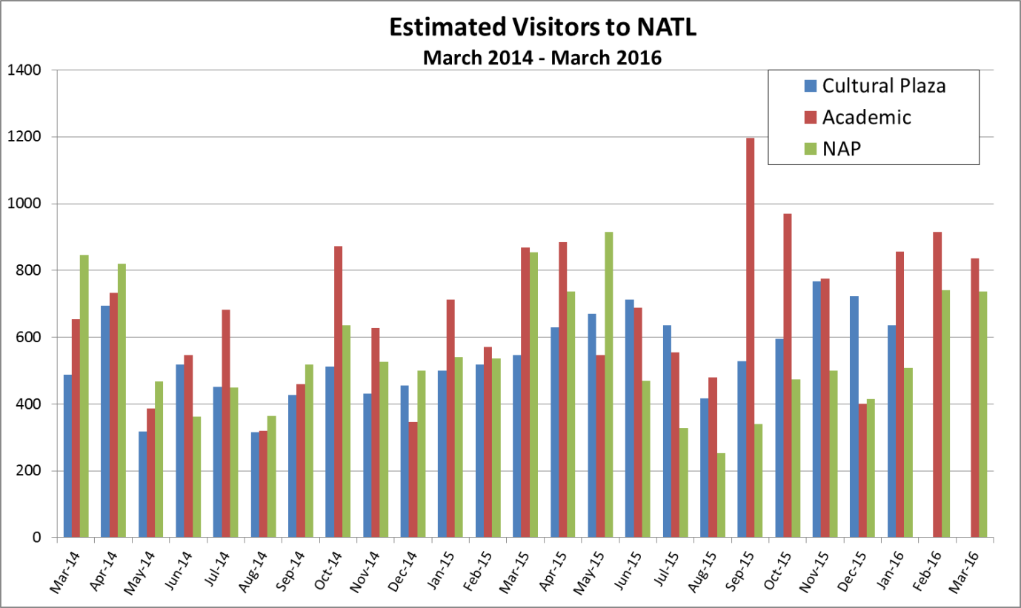

**Figure 1. Summary of TrailMaster counts from March 2014 to March 2016 at the Cultural Plaza, Academic and NAP entrances.** All numbers are TrailMaster counts/2 because users are counted twice, as they enter and exit.

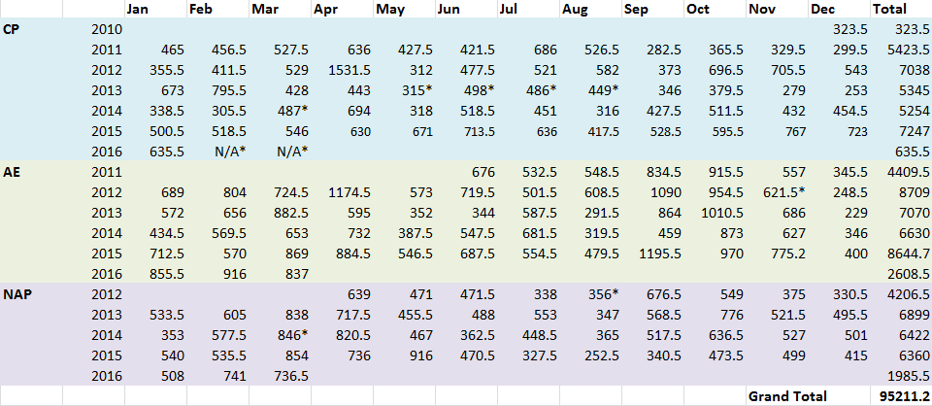

**Figure 2. Summary of NATL usage estimates via TrailMaster counts.** All numbers are TrailMaster counts/2 because users are counted twice, as they enter and exit.

*Technical difficulties, possibly due to the laser sensitivity setting, resulted in no data. Number provided is an average of the previous and subsequent years’ counts.

**Appendix 5:**

Since the last NAAC meeting in September 2015, NATL has hosted a number of volunteer events. Volunteers at these events worked to remove invasive species, collecting trash, cleaning signs, trimming trails and along fences. These events brought 40volunteers who worked a total of 123.5 hours. In addition, Tom Walker, Hector Lacera, and Sara Alvarez collectively donated­­ 377.5 hours of their time to NATL.

**Table 2. Volunteer Events**

|  |  |  |  |
| --- | --- | --- | --- |
| **September** | **November** | **January** | **March** |
| 9/19/15 UF Center for Leadership and Service volunteers help clean signs, pick up trash, and trim trails during Gator Plunge  (13 people x 3.5 hrs) **45.5 hrs** | 11/20/15 Operations Committee and volunteers remove young, invasive Coral Ardisia plants from the Hammock  (6 people x 2.0 hrs) **12 hrs** | 01/18/16 UF Center for Leadership and Service volunteers help clean signs, pick up trash, and trim trails during MLK Day of Service  (16 people x 3.5 hrs) **56 hrs** | 03/12/16 Operations Committee and volunteers remove trash and yard waste from NATL fences  (5 people x 2 hrs) **10 hrs** |

**Table 3. Volunteer Hours September 2015-April 2016**

|  |  |
| --- | --- |
| Miscellaneous Volunteer Projects | 123.5 hours |
| Tom Walker | 121 hours |
| Hector Lacera | 103 hours |
| Sara Alvarez | 30 hours |
| **Total** | 377.5 hours |

**Figure 2. Volunteer Hours Reported at NAAC Meetings- Spring 2012-Date.**

**Appendix 6: Control of invasive exotic plants in NATL**

In 2012, Ethan and Tom Walker prepared a summary of efforts to control NATL’s invasive plants from 1994 to May 2012. [That summary](http://natl.ifas.ufl.edu/docs/Efforts_to_control_invasive_exotic_plants_in_NATL.docx) is currently on the web. Afterwards we reconsidered which species were the greatest threat to NATL and assigned the species of greatest concern to places in a [new classification](http://natl.ifas.ufl.edu/docs/NATLinvasivesJuly2012.pdf) of NATL’s invasive plants. Now we are working on a framework to report annually the status of NATL’s invasive species of greatest concern in a straightforward, revealing manner. Below are examples of how this framework may operate. These are taken from a spreadsheet that has notes within certain cells to explain the details.

**Table 4. Status of exotic plants in NATL 2010 to present.**



**Status of Control of Invasive Plants in NATL**

NATL has approximately 142 plants that are not native to Florida, but only about 25 of these are currently under strict surveillance because of their perceived potential to significantly alter NATL ecosystems. An invasive plant will naturalize on its own, and take over native ecosystems by choking out and outcompeting natives. FLEPPC (Florida Exotic Pest Plant Council) maintains a list of all invasive plants in Florida, ranking them as either category 1 or 2. Category 1 plants are the most lethal and displace native plants, disrupting ecosystems, while category 2 plants can spread but have not yet necessarily altered ecosystems severely enough to be categorized as 1.

At NATL, we use both mechanical and chemical techniques to control invasive plants. A few common invasive plants that you may recognize are mimosa, Chinese tallow and camphor tree. To date the only invasive plant eradicated from NATL was elephant grass, however all of our documented invasive plants have been severely diminished and are controlled. We define “eradicated” as being absent with no sightings in NATL for a minimum of 3 years. There are currently seven plants that have not been sighted in several months, with no known existing infestations awaiting treatment. The common names of these species are air potato, pindo palm, silverthorn, negundo chastetree, chinaberry, wandering Jew, and Japanese loquat. It is expected that they are no longer found in NATL, but have not yet reached the 3 year mark to be classified as eradicated. A large patch of Asparagus fern was also treated recently, and it is believed to have been the only location in NATL. Four of the remaining invasive species that cause the most concern are cogon grass, skunk vine, coral ardisia, and Japanese climbing fern, which are all category 1 (FLEPPC).

Top category 1 plants in NATL include cogon grass (*Imperata cylindrica*), coral ardisia (*Ardisia crenata*), cat's claw vine (*Macfadyena unguis-cati*), air potato (*Dioscorea bulbifera*), skunk vine (*Paederia foetida*), and Japanese climbing fern (*Lygodium japonicum*). Category 2 plants include but are not limited to paper mulberry (*Broussonetia papyrifera*), silverthorn (*Elaeagnus pungens*), and Chinaberry tree (*Melia azedarach*). More information about invasive plant management in NATL can be found on the NATL website (<http://natl.ifas.ufl.edu/biota/invasive_control.php>).

**Appendix 7: NAAC roster Spring 2016**



**Appendix 8: NAAC Group Photo**

