**Fall 2016 Meeting of the Natural Area Advisory Committee – Agenda**

15 September 2016, NATL Academic Pavilion, 12:05-1:00pm

In attendance:

Morgan Byron (NATL Graduate TA)

Brittany Campbell (Entomology and Nematology Student Organization)

Jennifer Gillett-Kaufman (Entomology and Nematology)

Gail Hansen de Chapman (Lakes, Vegetation, and Landscaping Committee)

Laura Harmon (NATL Wildlife Ecology and Conservation Intern)

Jessica Hong (NATL Invasive Species Intern)

Susan Jacobsen (Environmental Education, Wildlife Ecology and Conservation)

Erik Lewis (Facilities Planning and Construction)

Alex LoCastro (NATL Undergraduate TA)

Scott Robinson (Florida Museum of Natural History)

Sean Sharp (Wetlands Club)

Thomas Walker (Friend of NATL)

Emma Weeks (NATL Chair)

Christina Romagosa (Wildlife Ecology and Conservation)

12:05 PM

**Introductions (Emma)**

Emma began the meeting by thanking all NAAC members for attending. Everyone introduced themselves and the NATL Operations Committee had a chance to greet the new members of the NAAC.

**1. Budget FY 2016 update- fiscal report on adherence to and/or deviation from 2015-2016 spending plan (Appendix 1, 2)**

Emma explained the fiscal sheets and budget plan included with the Agenda, as Lary, who is usually in charge of this portion of the meeting, was out of town doing field work. Emma described the values in the budget for 2015-16 (**Appendix 1**), explaining that the money brought forward last year was used for the burn this year, which encompassed all of the upland pine area at once. Income is the same as NATL usually receives, and the increased number reflected in the spreadsheet is not because more money is necessarily coming in, it is just a more accurate figure. Personnel expenses shown are greater than usual, which is due to the unique situation in the Summer semester, where only one graduate TA (Morgan) was working, and the money for a second TA was used to pay for burn coordinator (Ross Danson) and wildlife intern (Laura Harmon) positions. The money allotted for invasive species is what is used to pay invasive species intern, Jesh Hong, the funds for which are matched by UF Sustainability. Miscellaneous expenses were lower than average, which helps even out the slight overspending of the funds allotted for upland pine restoration.

The fiscal plan for 2016-17 (**Appendix 2**) was approved at the Spring 2016 NAAC meeting. Emma asked the group if they had any questions about either the current budget or the approved budget for next year, and no questions or concerns were raised.

**2. Updates on possible capital improvements and funding sources (Appendix 3)**

Emma began by describing the recent pavilion upgrades that have been completed. Namely, the pavilion now has a drinking fountain with both a bottle filler and a spigot. Water was rerouted from a nearby building to make this project possible. In the future, water will hopefully be available at the NATL shed, just down the trail from the pavilion, to facilitate pressure washing of the shed and other chores.

Additional improvements to the pavilion are taking longer than expected, though PPD did repaint the existing picnic tables as well as three new tables. Soon, they will begin replacing the wood on the tables in Natural Area Park (NAP). NATL is already in possession of lockers (visitors will provide their own padlock) that need to be installed in the pavilion. The installation of a whiteboard at the back of the pavilion is still a plan moving forward.

Emma also mentioned the experimental plots in the Restricted Area Upland Pine that will hopefully serve an educational purpose regarding ecosystem restoration. Each plot demonstrates a different method of restoration to be compared to the surrounding area that underwent a prescribed burn. Plots feature mowing and herbicidal treatment (by Jesh) as their methods for removing unwanted vegetation.

**5. People Counter Summer (Appendix 4)**

Alex described the process by which NATL counts its visitors, the values of which can be found in two figures (**Appendix 4**). July’s numbers were astronomical due to the popularity of Pokémon Go, a smartphone game that encourages players to walk around and explore areas in their community, released on July 7th 2016. The Florida Museum of Natural History had an event focused on this game on July 15th, a portion of which took place in NATL. On that day, the Cultural Plaza entrance TrailMaster (the one nearest the Museum) counted approximately 7.5 times the average number of visitors recorded for the rest of the month. Alex described the difficulty of getting accurate values for visitors in the month of July due to how the monthly totals are calculated – in part, by an average visitors per day value generated by adding up the month’s total and dividing by how many days for which data was recorded. The TrailMaster will stop recording data once it reaches a certain (very high) number, which was achieved part-way through the month of July. This led to difficulty in arriving at a visitor average for this month. The very large number from July 15th was removed from the total when calculating the average per day, in an attempt to estimate a more accurate monthly total. Nevertheless, visitor numbers for July 2016 were record highs for each entrance, and the total number of visitors since the TrailMaster units were first installed has now reached over 100,000.

**6. Volunteer Summary (Appendix 5)**

Morgan explained the graph and table shown in **Appendix 5** that depict volunteer activity in NATL based on planned events. Regular volunteers Tom Walker and Monica Camacho added to the total hours volunteered in NATL. Based on the graph, volunteer hours are lower than usual, but that is likely because it is an in-between time in the NATL events calendar. For example, Gator Plunge, a Center for Leadership and Service yearly service day, is planned for next weekend, and this event provides many volunteer hours for NATL. The Wetlands Club will be hosting some volunteer days soon, as they prepare to put their SEEP improvement plan into action.

**7. Minigrant update and 2016 planning**

Morgan gave an update on the status of last year’s minigrant projects. Of the minigrants awarded last year, Andrew Nisip’s project about ant diversity in NATL is nearly finished. This project will add to information found on the NATL website and result in a PDF document that can be used by visitors and by the TAs at outreach events. The project about eastern newt feeding preferences, proposed by Allan Gonzalez and Dr. Steven Johnson, will be completed at a later date – progress was stalled for a variety of reasons over the summer.

New minigrant applications are due soon – **November 2nd, 2016**! If you are aware of an undergraduate or graduate students (or groups of students) interested in completing a project that will benefit NATL, please direct them to apply. More information can be found on [the minigrant section of the NATL website](http://natl.ifas.ufl.edu/minigrants.php).

**8. Social media updates**

Morgan explained that at the time of the NAAC meeting, NATL’s Facebook page had 1,098 Likes and the Twitter page had 1,120 Followers. Since the last NAAC meeting in September, NATL had gained 48 Facebook Likes and 136 followers on Twitter! The NATL Instagram account, created in June 2015, had 326 Followers, 83 more than the number of followers at the Spring NAAC meeting.

If you use social media, please follow NATL on [Facebook](http://www.facebook.com/NATL.UF), [Twitter](https://twitter.com/UFNATL), and [Instagram](https://instagram.com/natl.uf/). The NATL Operations Committee makes an effort to post several times a week about what is going on in NATL. We also love posting about visitors using NATL, so please share any pictures or observations with us on any of these social media accounts.

**9. Control of invasive exotic plants in NATL (Appendix 6)**

Jesh explained what she has been working on in regards to the invasive species management in NATL. The table she put together for the agenda (**Appendix 6**) describes the worst Category 1 weeds found in NATL, in terms of quantity. Her main strategy has been to spot-treat areas where these invasive plants have been known to occur. Her current focus species is Guineagrass, which can be found in many areas throughout NATL. Jesh has also recently received her pesticide applicator license for spraying in aquatic areas, and she hopes to help combat some of NATL’s aquatic weeds, particularly in NATL-east. Looking at the graph, Jennifer Gillet-Kaufman asked where the air potato can be found growing. Jesh responded that it is mostly in the western portion of the Hammock. Erik Lewis asked how Jesh was able to remove this stubborn plant and Jesh responded that she dug it up. Erik went on to ask if the camphor tree numbers found in the table were a result of a new infestation and Jesh explained that the proliferation of this tree is due to a neglected spot with a known population of camphor. Emma told the NAAC what a great job Jesh has been doing, punctuated by the fact that NATL’s previous invasive species manager, Ethan Carter, checked some of his stand-by spots looking for invasive species to photograph and could not find any growing!

**10. Nature trail update**

Alex described how we maintain our trails to a height of 80 inches to be compliant with the Americans with Disabilities Act (ADA) and how the NATL TAs, along with volunteer, Monica Camacho, routinely trim the nature trails and roads. Volunteer groups also help to trim and pick up trash.

Alex explained plans to restart some of the Old-field plots. In February, the northeast portion of Old-field Plot B was successfully restarted and the southwest portion of Plot B is set to be restarted this fall, likely in October. Preparations will soon begin for the Fall 2017 restart of Plot D. As is the case with our Plot E preparations, this process entails the mechanical removal of hardwood species from the plot and an herbicidal application to their stumps. Plot E’s restart is still set to occur in 2020.

Alex also mentioned the potential need for replacement boards on the SEEP boardwalk following a short flooding event this summer. Sean agreed that the Wetlands Club would look into it and mentioned that during the last board replacement, he noticed that some of the support tresses on the boardwalk are looking a little worn. Emma asked if they needed to be completely replaced and Erik Lewis suggested that the entire boardwalk may need reworking but that the project should wait until the pilings start to show wear. He also suggested applying for an Environmental Stewardship grant through the university when the boardwalk needs an overhaul. Jennifer liked this idea, as Student Government money is used for the grant and two active clubs (ENSO and Wetlands Club) are regular users of NATL.

**11. SEEP restoration project**

Sean Sharp, the SEEP liaison, brought to the NAAC’s attention that the Wetlands Club plans to initiate a restoration of the SEEP area. This was mentioned at the last meeting, but action has not been taken yet. The plan involves vegetation management to return the SEEP to how it was designed, to provide maximum benefit to the ecosystem. Sean described how the SEEP cannot be managed like other natural areas or parts of NATL (using prescribed burning, for example) and so undesirable trees will be mechanically removed. These are mostly willow and oak species, the removal of which will mimic results produced by a controlled burn. Removing select vegetation will allow for the SEEP to function properly as a wetland ecosystem and increase visibility for visitors of NATL. Most of the plants are thought to fall below the size threshold that requires LVL review before removal, but a proposal and NATL walk-around to talk about the project will be scheduled and sent out before the project begins. Jennifer asked if the trees will be dug out and removed. Sean replied that any large ones will be cut down and their stumps treated with herbicide. Tom Walker added that trees on the east side of the SEEP trail may need to be thinned out, as that was in the original SEEP plan and management of that area has fallen by the wayside in recent years. Jennifer then moved to approve the Wetlands Club project and it was approved by the NAAC as a whole.

**12. Wildlife cameras**

Laura Harmon, previous NATL wildlife intern, described the difficulties the TAs have been having with getting the first wildlife camera’s live feed to be accessed outside of the university’s computer network. There is currently [a page on the NATL website](http://natl.ifas.ufl.edu/naturetrails/SEEPtrailcam.php) that receives the live feed from the camera, but it can only be viewed on campus.

Laura went on to explain the other cameras used in NATL: a trail cam used to monitor terrestrial wildlife and a burrow scope cam. The trail cam was used in NATL-East, and found marsh rabbits near the back portion of the central marsh, close to the boardwalk. Surveys of burrows in NATL-West have been done with a scope camera. With this camera, the location of a gopher tortoise in the upland pine area, and several other burrows belonging to armadillos, a possible cottontail rabbit, and small rodents have been identified.

**13. Restoration of Upland Pine (Appendix 7)**

Emma briefly recapped the successful burn of the entire upland pine area lead by Tom Workman on March 2, 2016. In blocks A and B, the public area upland pine, burn coverage was estimated at 100 percent. In blocks C, D, and E, the restricted area upland pine that is notoriously more difficult to burn, burn coverage was estimated at 95%, 85%, and 85%, respectively. In the future, we plan on a complete burn of the Upland Pine area once a year.

Early this year, members of the NATL staff outlined a demonstration area to contrast three upland pine restoration treatments: burning, mowing and herbicide. The demonstration area is situated on the western end of the restricted area (**Appendix 7**). Half of an area, 50 meters wide by 200 meters long, was designated to demonstrate an herbicide treatment, and the other half of the area was designated to demonstrate a mowing treatment. To contrast these two treatments to the more traditional treatment of prescribed burning, the demonstration area was isolated from the prescribed burn in March 2016. In late March the mowing treatment was completed. The herbicide treatment was completed in late Spring-early Summer. Just as the prescribed burn occurs annually, the mowing and herbicide treatment will be implemented annually.

Jennifer asked if more wiregrass in the restricted area upland pine would help get burn coverage closer to 100%. Tom Walker responded that there is some wiregrass there, but that many of the plugs planted in previous years did not survive because they were largely shaded out by more established plants. Alex proposed planting other fire-friendly grasses and Erik suggested that may not work well because grasses like Muhly grass need regular irrigation to establish, as seen in landscaping on main campus.

**Next NAAC meeting date and time**

Emma wrapped up the meeting by telling the NAAC that NATL is always looking for new, regular volunteers as this is how we fill other positions when they open up. We currently are looking for a new undergraduate TA and, at the end of the year, will be seeking another invasive species intern.

**Next meeting date proposed:** April 13, 2017, noon at the NATL pavilion.

**1:00 PM Meeting Adjourns**

**Appendix 1**



**Appendix 2**

**Fiscal Plan for FY 2016-17**



**Appendix 3**

**Capital Improvements Updated Fall 2016 Report**

The following items were discussed and compiled by the NATL Operations Committee and modified based on a week’s discussion by NAAC members. Some items have an associated web link that is an example of the item described.

**Long Range NATL Wish List: 2011-2021 Vision Plan**

We recognize that NATL already has tremendous value to the local UF community. This Vision Plan seeks to strengthen and enhance these indigenous values of NATL and, in addition, provide mechanisms for bringing the educational values of NATL to an unlimited online environmental community of users. We present the plan in the form of a two-part outline of infrastructure and other developments, focusing on both in-person and online users of NATL.

This list is not static; additional items may be added to the list. Items will be removed from the list if more than half of the NAAC members feel that the item would not enhance the use of NATL.Funding for items could come from donations to the UFF on behalf of NATL or by writing specific items into future grant proposals.

**A. Enhancing in-person access**

1. ~~Bike parking areas at each primary NATL entrance.~~ Completed 2012.
2. ~~Extend 110v AC to the pavilion and the NATL shed (two weather proof duplex outlets at the pavilion and hook up the wiring that came with the prefab storage shed).~~ Completed 2013.
3. ~~Extend potable water service to the pavilion area to provide access to water for drinking, bottle filling, hand washing, and class-related low-volume uses. This could include a sink and associated drain board if restraints on cost, design, and context are met.~~ Completed 2016.
4. Two or more locking cupboards for class use (to reduce the risk associated with students leaving valuables unattended in the pavilion during class time). (Design and placement not yet considered.) Lockers acquired FREE will be secured in Pavilion by PPD.
5. Natural Area Park water fountain. (Design and placement not yet considered.)
6. Additional seating areas at NATL Park and along NATL trails. (If the UF Foundation approves the plan, donors might pay enough for benches with commemorative inscriptions to fund other items on this wish list). [LINK](http://www.parkbenchsource.com/product-base/4-ft-park-benches/luma-bench)
7. Add a classroom and/or lab building to facilitate NATL use. To avoid using land in the NATL-west Conservation Area, the building might best be situated on an out-parcel south of the pavilion. (A representative of the UF Foundation believes NATL might attract a donation of $1 million or more. Having a plan for using such a donation might help the donor decide to make it. An alternative plan for using such a donation would be to set up an endowment for the benefit of NATL.)
8. ~~Improve access to NATL nature trails from Cultural Plaza for those with disabilities. New boardwalk/ramp from Cultural Plaza entrance, curb dropped and all trails trimmed to 80 inches in height to be compliant with the Americans with Disabilities Act (ADA). (Trimming has been initiated and we are awaiting a quote from a contractor for the boardwalk/ramp.)~~ Completed 2015.
9. Pavilion upgrades selected based on feedback from the NATL user survey including a white board for writing or projecting on, extra tables, lockers and potable water. Funding for white board, extra tables (including refinishing of all tables, replacement of wood on tables in NAP) and lockers from CALS. Waiting on PPD.

**B. Instituting remote access (and security) and real-time online interaction with NATL**

1. ~~Update the look of the NATL website while improving its usefulness as a distance natural laboratory. This change will maintain the historical information on the website now; it will not be lost in the change--just repackaged.~~ Completed 2012. ~~Website additions could include a NATL "virtual collection"/species inventory with photos and audio recordings of sounds such as resident bird, frog and insect calls for groups interested in taking virtual field trips.~~ Completed 2013.
2. ~~Complete and enhance Wi-Fi coverage in NATL. With this, we could lead live tours of NATL using camera abilities built into iPads and other electronic devices. This would allow teachers and students the ability to direct the tour by asking their NATL tour guide to zoom in on subjects of interest. This would be a wonderful opportunity for our students in the ecotourism track to lead tours for students around the world.~~ Completed 2014.
3. ~~Install webcams in NATL at carefully selected venues. These cameras could be used by researchers studying animal behavior in NATL as well as giving access to NATL to teachers in their classrooms. Example of broadcasts: LINK~~ Completed 2015
4. In partnership with FLMNH, develop a program using an interactive whiteboard (e.g., SMART board) to use digital material from NATL to involve K-12 students in learning about ecological concepts and problems. Including grade-level specific, standards-based curriculum materials (field investigation activities) that can be implemented as part of school field trips or summer enrichment programs. Make available as downloadable files for use by home schooled children, scout groups and others.
5. Prepare pre-recorded guided tours that will be filmed and then available online for those that cannot visit NATL in person. Offer live guided tours for schools and other groups of people that would not be able to visit NATL in person due to distance from the site or disability. In progress – NATL Undergraduate TA Alex LoCastro is filming nature trail tours as part of an internship.

**C. Enhancing the research and teaching usage of NATL**

In collaboration with the School of Forest Resource and Conservation (SFRC), the NATL Operations Committee is discussing the implementation of several demonstration plots in the Restricted Area Upland Pine. Depending on the needs of SFRC and other users plots could include those that have been managed with burning, herbicides, mowing and combinations thereof, as well as different planting techniques. Completed 2016.

Establish a grant program costing approximately $10,000 a year providing small grants ($500-$5,000 grants) to foster data collection, proposal submissions and distance curriculum development utilizing NATL. Distance curriculum developed using seed grant funding would be made freely available on the NATL website. $1,000 per year earmarked for a grant that would support one or more citizen science projects in NATL. Citizen Science projects could fund some NATL specific ideas as well as support the partnership of NATL with national initiatives.

**Appendix 4**

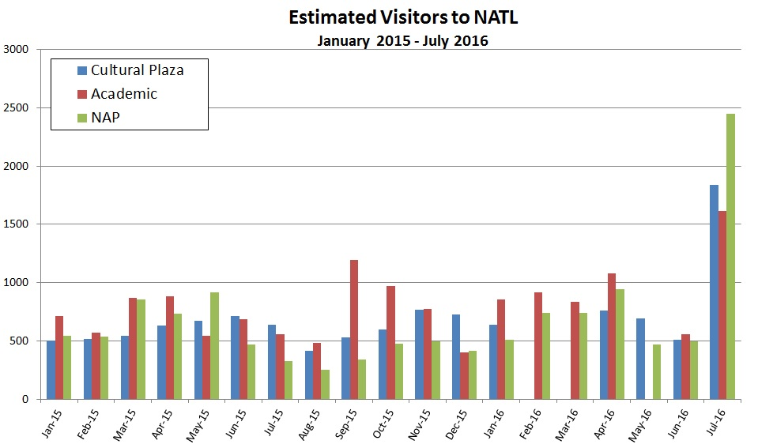

**Figure 1. Summary of TrailMaster counts from March 2014 to March 2016 at the Cultural Plaza, Academic and NAP entrances.** All numbers are TrailMaster counts/2 because users are counted twice, as they enter and exit.

**\*** Extraordinarily high July 2016 numbers can be attributed to the release of PokémonGo on July 7th and the Florida Museum of Natural History’s PokémonGo event on July 15th. Visitor counts around these events were so large that the TrailMasters maxed out early on in the month, ultimately causing an over-inflation of the July data due to the low number of full days where data was recorded. This is because our algorithm calculates the average number of counts per recorded day and then estimates the month’s total by multiplying the average by total days in the month. Data on July 15th in particular was abnormally high (visitor counts for the Cultural Plaza entrance was 7.5 times higher than the rest of the month’s average) and greatly skewed the average number of counts per recorded day. Because of this, July 15th numbers were excluded from being calculated into the average and then added in after the rest of the month’s data was estimated.

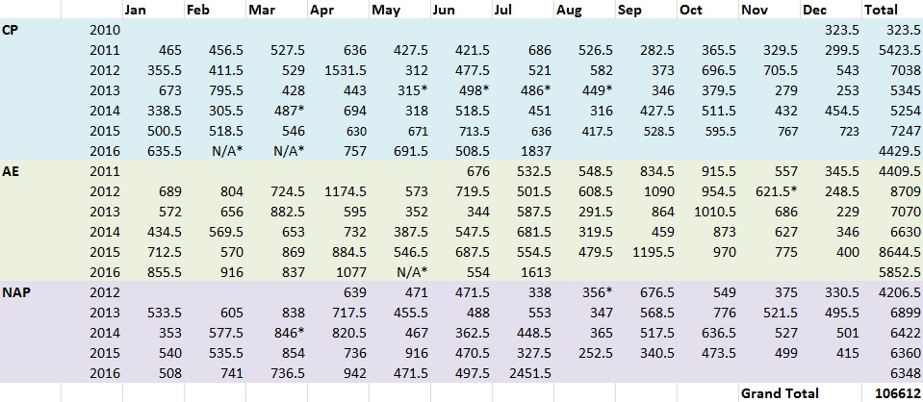

**Figure 2. Summary of NATL usage estimates via TrailMaster counts.** All numbers are TrailMaster counts/2 because users are counted twice, as they enter and exit.

*Technical difficulties, possibly due to the laser sensitivity setting, resulted in no data. Number provided is an average of the previous and subsequent years’ counts.

**Appendix 5**

**Table 2. Volunteer Events**

|  |  |  |
| --- | --- | --- |
| **April** | **June** | **July** |
| 4/13/16 NATL volunteer Hector Lacera and 3 additional volunteers work to clean up nature trails  (4 people x 2 hrs)  **8 hrs** | 6/11/16 Volunteers from UF Innovation Academy Serve remove litter and debris fallen after a storm (9 people x 1.5 hrs)  **13.5 hrs** | 7/23/16 UF Center for Leadership and Service volunteers help remove litter and trim trails during Summer Plunge  (18 people x 3.5 hrs)  **63 hrs** |

**Table 3. Volunteer Hours September 2015-April 2016**

|  |  |
| --- | --- |
| Miscellaneous Volunteer Projects | 84.5 hours |
| Tom Walker | 48 hours |
| Monica Camacho | 16 hours |
| **Total** | **148.5 hours** |

**Figure 2. Volunteer Hours Reported at NAAC Meetings- Spring 2012-Date.**

**Appendix 6**

**Status of Control of Invasive Plants in NATL**

The table below is a summary of some of the top invasive species removed in NATL.  
The numbers indicate how many individual plants were managed.

|  |  |  |  |
| --- | --- | --- | --- |
| Species name | Common name | 2015 | 2016* |
| *Albizia julibrissin* | Mimosa | 814 | 161 |
| *Ardisia crenata* | coral ardisia | 959 | 119 |
| *Broussonetia papyrifera* | paper mulberry | 16 | 69 |
| *Cinnamomum camphora* | camphor tree | 42 | 802 |
| *Dioscorea bulbifera* | air potato | 1 | 7 |

*Indicates the year is not over yet and thus, additional plant removal may be added in in the future.

Currently, guineagrass is one of the most abundant invasives in NATL, which predominantly occurs in the old field and upland pine areas. Individual plants may be difficult to quantify, thus it is not included in the chart above. So far, approximately 3.5 acres have been treated throughout NATL.

Top FLEPPC category 1 plants in NATL include cogon grass (*Imperata cylindrica*), coral ardisia (*Ardisia crenata*), cat's claw vine (*Macfadyena unguis-cati*), air potato (*Dioscorea bulbifera*), skunk vine (*Paederia foetida*), and Japanese climbing fern (*Lygodium japonicum*). Category 2 plants include but are not limited to paper mulberry (*Broussonetia papyrifera*), silverthorn (*Elaeagnus pungens*), and Chinaberry tree (*Melia azedarach*). More information about invasive plant management in NATL can be found on the NATL website (<http://natl.ifas.ufl.edu/biota/invasive_control.php>).

**Appendix 7**

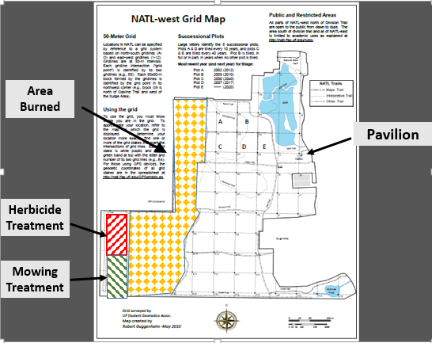

**NATL campus visibility**

Morgan spent half of the Summer semester learning web development techniques and hopes to enhance the layout and accessibility of the NATL website. A complete redesign is the ultimate goal, with an interactive map tool and greater emphasis on interaction between students, the public, and NATL.

We are getting several new signs and updating some of the old ones. For example, we will have a new sign on Museum Road by the lacrosse field.

**NAAC roster Fall 2016**

**NAAC Group Photo Fall 2016**