Eradication of Coral Ardisia (Ardisia crenata) in NATL
T. J. Walker, April 2012
This report, or an updated version of it, with live links, is at http://natl.ifas.ufl.edu/ardisiaplan.pdf.
Executive summary
Coral Ardisia is an understory shrub that is a major threat to the hardwood hammocks of north Florida. Once established, it rapidly spreads and produces stands so dense that it dominates the understory. The species is native in India and Japan but was introduced to the southeast U.S. as an ornamental shrub for its glossy green foliage and bright-red, persistent berries. When NATL was established in 1994, portions of its hammock were already heavily infested. A concerted effort to eradicate Coral Ardisia from NATL was begun in 2010, and by March 2012, berry production by Coral Ardisia in NATL had almost ceased. Because the species produces no seeds that can survive at typical field temperatures beyond a few months and because the persistent red berries make mature plants easy to find, only minor resources should be required to keep NATL free or nearly free of Coral Ardisia in the future.
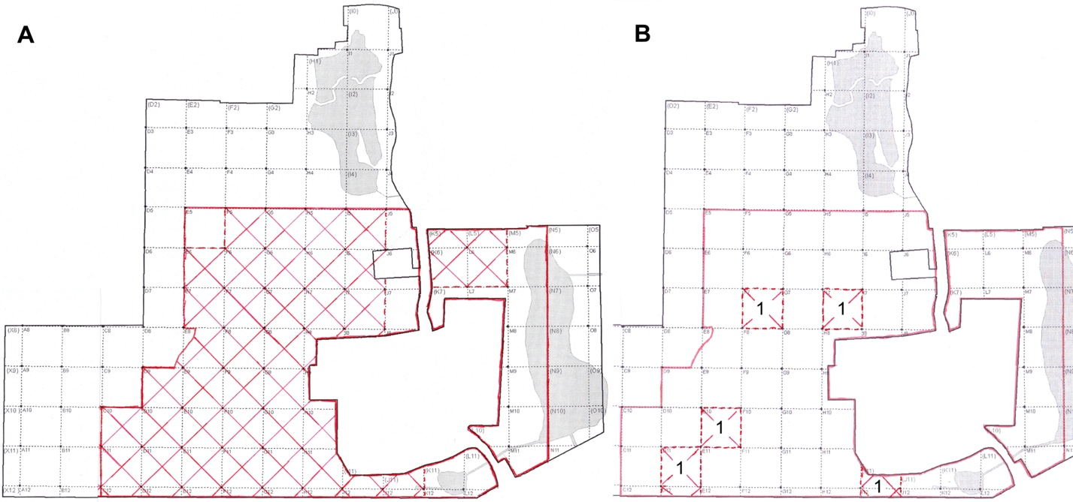
Fig. 1. Maps showing NATL’s 50x50m grid system. A. Areas monitored for Ardisia are within a solid red line and are divided into 57 “Ardisia reporting blocks.” In Feb. 2010, 41 of these blocks were known to have one or more mature Coral Ardisia. In both divisions of NATL, the infested blocks were contiguous and their limits are indicated by two cross-hatched areas—a large one in NATL-west and a much smaller one in NATL-east. B. Limits of monitored areas and infested area are indicated as before. The five reporting blocks with mature Ardisia early in 2012 each had only one berry-bearing plant.
Table 1. Progress toward eradication of Ardisia crenata from NATL hammocks: Numbers of plants with red berries in mid or late winter. (This same table, with footnotes added, is repeated later in this report.)
 | NATL-west  public | NATL-west  restricted | NATL-east | Sum | Decline from  prev. yr | Decline  since  2009
January 2009ª | 585 | >712 | No data | >>1297
February 2010 | 96 | 122 | 98 | 316 | >76% | >76%
January 2011 | 34 | 20 | 27 | 81 | 74% | >94%
March 2012 | 2 | 3 | 0 | 5 | 94% | >99%
Introduction
In 2009, Gerardo Celis and Corrie Pieterson were awarded a minigrant to study NATL invasives (http://natl.ifas.ufl.edu/minigrants.htm). A central feature of their work was mapping and mechanically removing Ardisia crenata from the infested areas in NATL-west. In their Final Report (http://natl.ifas.ufl.edu/Celis_Pieterson_finalrept.pdf), they reported
“We removed 1297 adults and 8397 juveniles/seedlings weighing a total of 373 lbs. While we were surveying the hardwood hammock, our initial impression was that the infestation was less severe in previously treated areas. However, the GIS maps (Figures 2 & 3) indicate that in comparison to the 2001 inventory there was no apparent difference in number of individuals present between areas where Ardisia had been treated previously and other areas (Figures 4 & 5).”
This was disappointing because substantial efforts to reduce Ardisia in NATL had been made during the two years prior to the minigrant work. However, re-reading the report of Fox and Kitajima (2001, http://natl.ifas.ufl.edu/Fox&Kitajima2001.pdf) on their studies of Ardisia life history made it seem logical to change the goal of Ardisia treatment in NATL from reduction to eradication.
Premises of eradication plan
These four considerations are critical to the success of the current Ardisia eradication plan:
- Ardisia has no seed dormancy
Fox and Kitajima (2001, p. 2) found “no evidence of internal seed dormancy mechanisms or soil seed banks” in Ardisia. Seeds that mature on the plants in NATL either germinate or die within their first year.
- Nearly all Ardisia seeds in NATL come from mature plants in NATL.
Fox&Kitajima (2001, p.26-28) found that most mature seeds stayed on Ardisia plants for months. In one study 50% of mature berries were still on the plants in mid April and 10% remained at the end of June. Most of the fruit that disappeared from plants simply dropped to the ground and could be recovered in trays placed on the ground beneath. They observed damaged fruit but had no information as to what species accounted for the damage and possible removal of fruit from the immediate vicinity of the plant. Except for a few small sites just beyond NATL’s south boundary and already tended to, no Ardisia-infested area is known from which flightless wildlife could conceivably transport seeds to NATL. Although transport of Ardisia seeds into NATL by birds or man may occur, it must be exceedingly rare.
- Mature individuals are unusually easy to spot once their berries turn red in late December.
Fox&Kitajima (2001, p.26) found that Ardisia plants flower in May, green fruit are generally present by early September, and most fruit do not “ripen to their mature red coloration until late December.” They did not study the relationship between fruit coloration and competence to germinate, but plants stripped of their green fruit prior to December will not be counted as potential contributors to the seedling cohort of the following year.
- A 2% aqueous foliar spray of triclopyr kills Ardisia plants.
Erick Smith (2009 and 2010, personal communications) emailed that 2% Garlon 4 in water with Dyne-Amic surfactant is effective against all stages of Ardisia and at all times of year; although in winter, plants may take 3 to 4 months to die.
Development of the eradication plan
In early February, 2010, when resources for Ardisia control became available, the initial plan was to study the possibility of Ardisia eradication in NATL-east by mechanical removal of root crowns and above ground parts of all berry-bearing plants. This plan quickly morphed into a plan to remove only the berries, mark the plant with a fluorescent pink flag, and kill it later with a foliar application of triclopyr. Berry removal in NATL-east was completed by mid February, and it was decided to extend the procedure to the rest of NATL. In NATL-west, areas that had been treated by Celis and Pieterson in 2009 proved to have much lower numbers of berry-

