Using spreadsheet to calculate average coverage in a block of Upland Pine
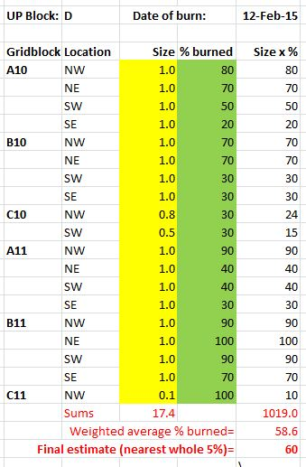
The spreadsheet BurnCoverage2013-date.xlsx simplifies estimation of the average coverage in any of NATL’s five blocks of upland pine based on the numbers entered on the BurnCoverageEstimationForm.docx. Many of the numbers entered estimate the % coverage for an entire 25x25m ¼-gridblock, but others estimate the coverage in a partial ¼-gridblock. Thus the spreadsheet must weigh each number entered from the estimation form by the area of the ¼-gridblock involved. How this is accomplished is illustrated in Fig. 1. In the yellow highlighted column, are the “weights” of the areas of the ¼-gridblocks used in estimating the average coverage in UP Block D. These range from 1.0 (100% of maximum area) to 0.1 (10% of maximum area). In the green-highlighted column are coverage estimates for each of the ¼-gridblocks (as read from this estimation form). The right-most column is the product of the numbers in the two highlighted columns to the left. Dividing the sum of the areas used (17.4) into the sum of the weighted estimates (1019.0) gives the weighted average % burned (58.6). Because this method of coverage estimation is too imprecise to justify so exact a number, the final estimate is expressed to the nearest whole 5% (60).
Fig. 1. Example of weighted average.
The spreadsheet facilitates entering the coverage estimates from the estimation form by asking for those numbers in an easy to use sequence: Starting at the 50x50m gridblock in the northwest extreme of the subject UP Block, it asks for the numbers for all of the relevant ¼-gridblocks of that gridblock; then it moves east to the next relevant 50x50m gridblock and does the same. When there are no more relevant 50x50m gridblocks to the east, it drops down to the next row of 50x50m gridblocks and continues as before; etc.

