University of Florida Natural Area Teaching Laboratory

2017 NATL Minigrant Program

In November 2016, UF’s Natural Area Advisory Committee (NAAC) will award up to two minigrants of up to $500 each to fund 2017 projects that enhance the information infrastructure of the Natural Area Teaching Laboratory (NATL). We seek projects that will produce useful new information about NATL or will improve access to what is already known.

Who is eligible? UF students or groups of students with a designated student leader.

Requirements
A student or group must have a sponsor who is a UF faculty member. The student or group, and sponsor, must prepare an application and submit an electronic version by email and a signed paper copy by campus mail. If accepted, a final report must follow completion of the project. This report should focus on the successes and limitations of the project and what was accomplished to further the mission of NATL. Examples of final reports can be found on the minigrant webpage. The application deadline is November 7th, 2016.

Examples of suitable projects
The projects listed below are provided to illustrate the type and scope of projects that the NAAC wishes to encourage, however we are open to any project that enhances the usefulness of NATL for teaching or research.
- Improve accessibility to critter cams.
- Look at seasonal cycles in NATL and put together a visual presentation (video or sign).
- Generate material that will encourage bird watching in NATL.
- Narrated virtual tours of nature trails.
- Evaluate how SEEP plays a role in the Hogtown Creek and Lake Alice Watersheds.
- Evaluate NATL’s seed bank in different ecosystems.
- Prepare a NATL video that could attract visitors to NATL’s table during events.
- Update the list and prepare a searchable database of NATL’s vascular plants.
- Prepare materials to highlight NATL’s interesting organisms, e.g. endangered species.
- Design a table display for NATL to use at events such as ButterflyFest and Earth Day.
- Feel free to be creative! Propose your own idea that could enhance the information infrastructure of NATL

How applications are evaluated
Proposals will be circulated among NAAC members. Members will have one week to discuss proposal merits and a second week to vote and make a final decision. Projects that produce tangible products that have direct benefits for NATL users will be prioritized. By November 30th, 2016 the NAAC chair will notify the applicants of the funding decisions.

Fiscal details
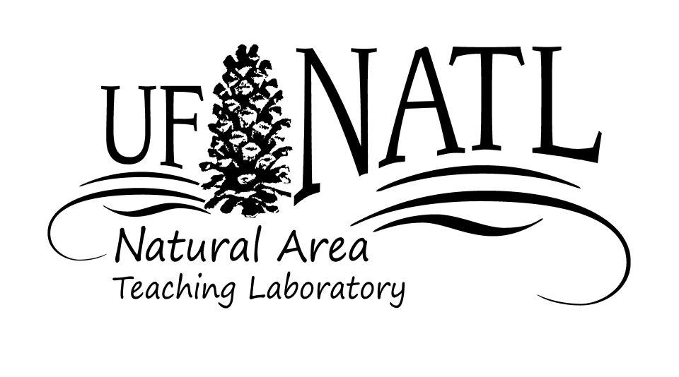
When a minigrant is awarded, the award will be made available for transfer from the NAAC account to a sponsor-designated account in the sponsor’s department. The sponsor will be responsible for seeing that an account is available to receive the transfer and that the money is used to support the project-related needs of the student proposer. If the funds exceed these needs, the faculty sponsor may use the money to support other aspects of the proposer’s or the sponsor’s program.
2017 NATL Minigrant Program - Application Instructions

Applications must be submitted by November 7th, 2016 as an MS Word or PDF file attached to an email message to natl@ufl.edu, with a signed paper copy sent by campus mail to Emma Weeks, NAAC Chair, PO Box 110620, Campus Mail.
To be considered, submissions must include the bold-faced items indicated below, and consist of no more than three pages.

Proposer or designated leader of a student group

Name

Academic classification

Department

Graduation Date

UF e-mail address

Postal address

Phone number(s)

Experience or training related to proposed project

Sponsor (must be a UF faculty member)

Name

Department

UF e-mail address

Campus-mail address

Phone number(s)

Title of project

Project summary- Should be no more than 150 words.

Starting date- Must be in the Spring 2017 semester.

Completion date- Must be no later than six months after starting date or prior to graduation if Spring 2017 is the student’s final semester at UF.

Description of project
Describe objectives, procedures, and any potential lasting impacts on NATL. Provide a budget that details how funds will be spent. The amount available is $500 maximum, there is no minimum amount. Tell what will be delivered to NAAC by the completion date of the project and how the results of the project will be of value to future users of NATL. All results must be delivered in digital format so they can be posted on the NATL web site at http://natl.ifas.ufl.edu.

Provision for periodic communication with NAAC administration
Describe how the NAAC Chair will be kept informed of progress on the minigrant project and have opportunities to offer help and advice. For example, while working on the minigrant, the proposer could meet monthly with the NAAC Chair. We also expect grantees to provide updates and pictures of their work for our Facebook, Twitter, and Instagram accounts.

Signatures

Only the paper copy needs to be signed.

Student_______________________________________ Date___________________

Sponsor_______________________________________ Date___________________

