Spring 2019 Meeting of the Natural Area Advisory Committee – Agenda
April 18, 2019, NATL Academic Pavilion, 1 pm
See Appendix 1 for roster of NAAC committee.

- Introductions (Emma)
- Fiscal report for FY 2018-2019 (Jesh, Page 2)
- Fiscal plan FY 2019-2020 (Jesh, Page 3)
- Updates on possible capital improvements and funding sources (Emma, Pages 4-5)
- NATL Use Report (Jen, Iona)
  - People counter summary (Jen, Pages 6-7)
  - Volunteer summary (Jen, Page 8-9)
- Mini-grant update and 2019 planning (Jen, Pages 9-10)
- Invasive plant update (Lexie & Ashley, Pages 11-12)
- Nature trail update, boardwalk concerns (Erika & Iona, Page 13)
- Old field update (Jen, Page 13)
- Restoration of Upland Pine (Jesh, Page 13)
- Plant inventories (Gage, Page 14)
- New chair needed by August 2019 (Emma)
- Vote, Next NAAC meeting date and time. Proposed Noon, September 12, 2019 or doodle poll

Fiscal plans 2018-2019, 2019-2020
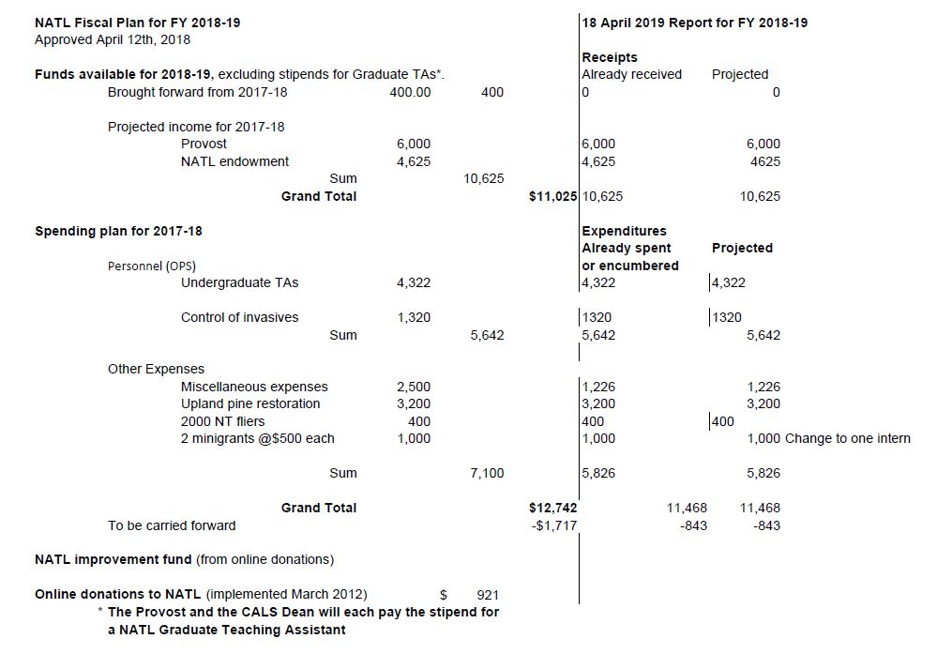
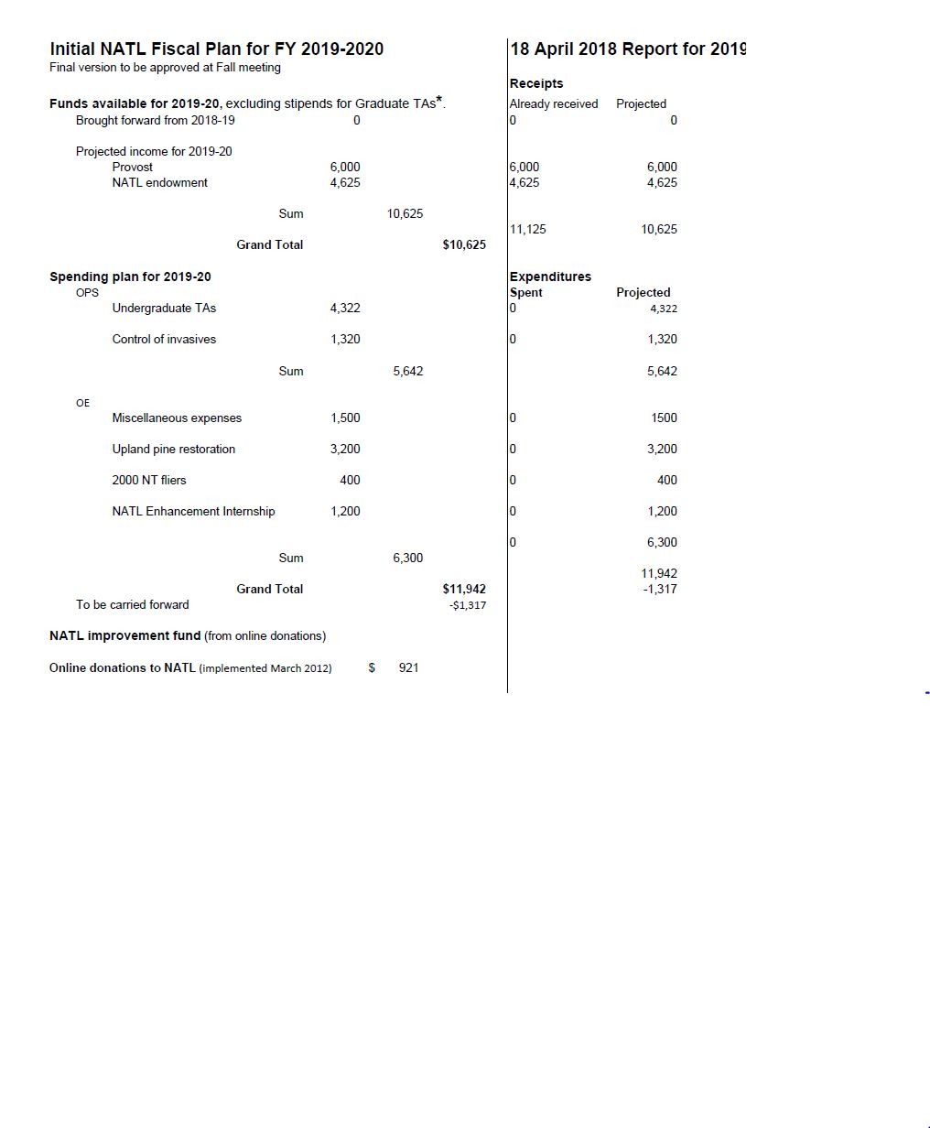
Capital Improvements Updated Spring 2018 Report

Long Range NATL Wish List: 2011-2021 Vision Plan
We recognize that NATL already has tremendous value to the local UF community. This Vision Plan seeks to strengthen and enhance these indigenous values of NATL and, in addition, provide mechanisms for bringing the educational values of NATL to an unlimited online environmental community of users. We present the plan in the form of a two-part outline of infrastructure and other developments, focusing on both in-person and online users of NATL.
This list is not static; additional items may be added to the list. Items will be removed from the list if more than half of the NAAC members feel that the item would not enhance the use of NATL. Funding for items could come from donations to the UFF on behalf of NATL or by writing specific items into future grant proposals.

A. Enhancing in-person access
- SEEP boardwalk. Now in a state of disrepair with large holes forming monthly. We are working with Facilities to get a quote for its repair/replacement.
- Trailmaster replacement
- Natural Area Park water fountain. (Design and placement not yet considered.)
- Add a classroom and/or lab building to facilitate NATL use. To avoid using land in the NATL-west Conservation Area, the building might best be situated on an out-parcel south of the pavilion. (A representative of the UF Foundation believes NATL might attract a donation of $1 million or more. Having a plan for using such a donation might help the donor decide to make it. An alternative plan for using such a donation would be to set up an endowment for the benefit of NATL.)
B. Instituting remote access (and security) and real-time online interaction with NATL

- In partnership with FLMNH, develop a program using an interactive whiteboard (e.g., SMART board) to use digital material from NATL to involve K-12 students in learning about ecological concepts and problems. Including grade-level specific, standards-based curriculum materials (field investigation activities) that can be implemented as part of school field trips or summer enrichment programs. Make available as downloadable files for use by home schooled children, scout groups and others. NATL TA Jennifer Eells is currently working on this. In progress- Upland pine ecosystems, Invasive Species and Fire Ecology lesson plans including information, glossaries, pictures, activities and questions are ready to be uploaded to the website.
- Prepare pre-recorded guided tours that will be filmed and then available online for those that cannot visit NATL in person. Offer live guided tours for schools and other groups of people that would not be able to visit NATL in person due to distance from the site or disability. In progress –Jen will incorporate this into the environmental education project with paired videos and study guides.

C. Enhancing the research and teaching usage of NATL

In collaboration with the School of Forest Resource and Conservation (SFRC), the NATL Operations Committee is discussing the implementation of several demonstration plots in the Restricted Area Upland Pine. Depending on the needs of SFRC and other users plots could include those that have been managed with burning, herbicides, mowing and combinations thereof, as well as different planting techniques. Completed 2016, ongoing.

Establish a grant program costing approximately $10,000 a year providing small grants ($500-$5,000 grants) to foster data collection, proposal submissions and distance curriculum development utilizing NATL. Distance curriculum developed using seed grant funding would be made freely available on the NATL website. $1,000 per year earmarked for a grant that would support one or more citizen science projects in NATL. Citizen Science projects could fund some NATL specific ideas as well as support the partnership of NATL with national initiatives.

Sarah Anderson, a student in Entomology, is studying the southeastern blueberry bee (Habropoda laboriosa) in NATL's old field plots (Figure 1). The tents you see are ones she erected to capture the bees as they emerge from underground (Figure 2). She will mark and release them to learn more about their biology.

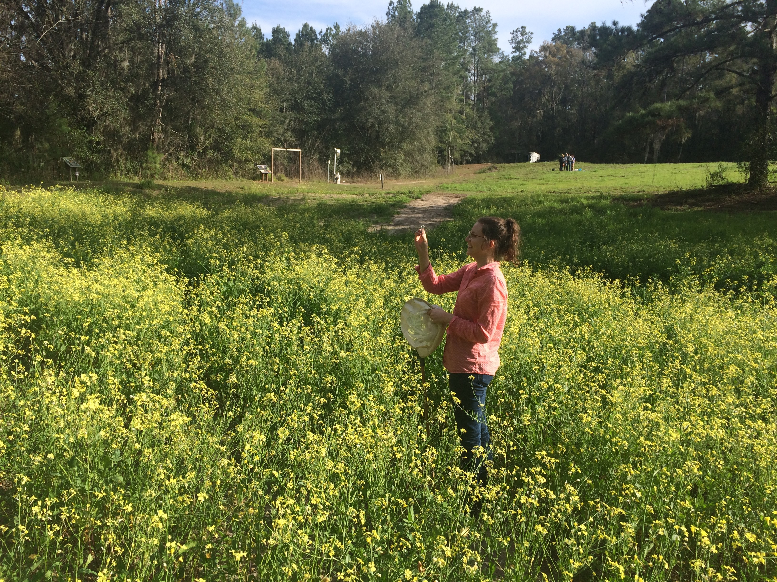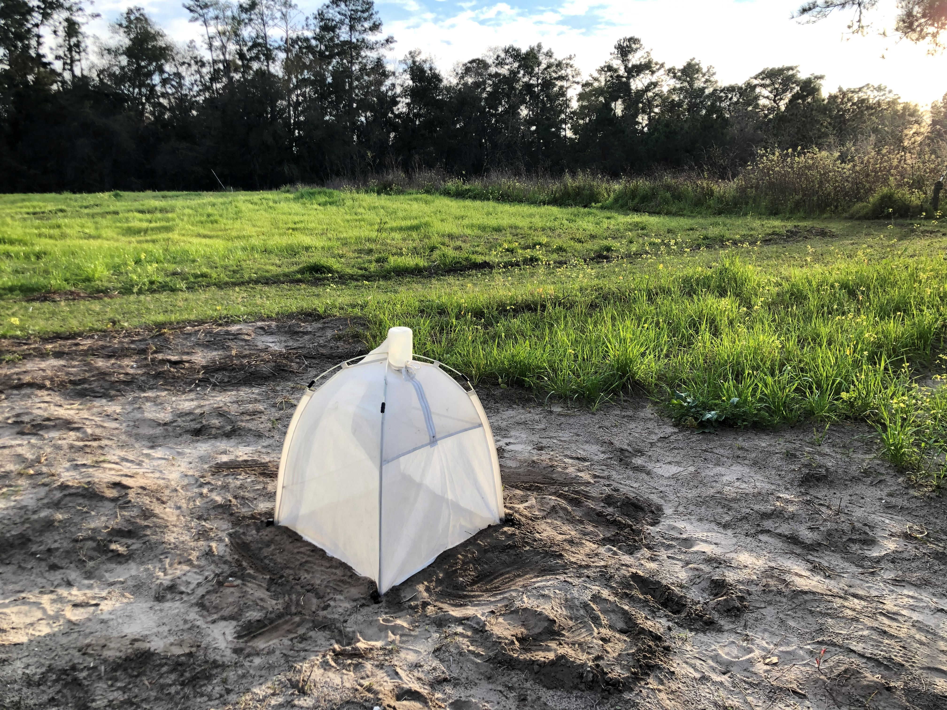
Figure 1 and 2. Sarah Anderson in the Old-field plot catching southeastern blueberry bees. The tents she erected over the bee’ holes to capture and mark emerging bees.

On March 21st, Jessica Hong and Gage Lapierre gave Dr. Mallinger’s pollution ecology class a tour of NATL. Emma Weeks also led a group of small school children on a tour of NATL and helped them to pick up trash.

TrailMaster/People Counter Summary

Three TrailMaster units are installed in NATL, one at the Academic, Cultural Plaza and Natural Area Park Entrances, respectively. These units measure NATL usage by counting the number of people passing through each entrance. The Cultural Plaza Entrance has had a TrailMaster installed since July 2010, however initial technical difficulties yielded unreliable data in the first few months. Subsequently, two additional units were installed at the Academic Entrance (June 2011) and Natural Area Park Entrance (April 2012). Figure 1 and Table 1 summarize information collected by the TrailMaster units. NATL visitors are counted twice (as they enter and exit), so all counts are divided by two to estimate the number of visitors NATL receives. Some technical difficulties related to battery failures provided unreliable data at the Academic Entrance throughout 2017 and 2018. New batteries and a new TrailMaster were installed and all issues seemed to have resolved.

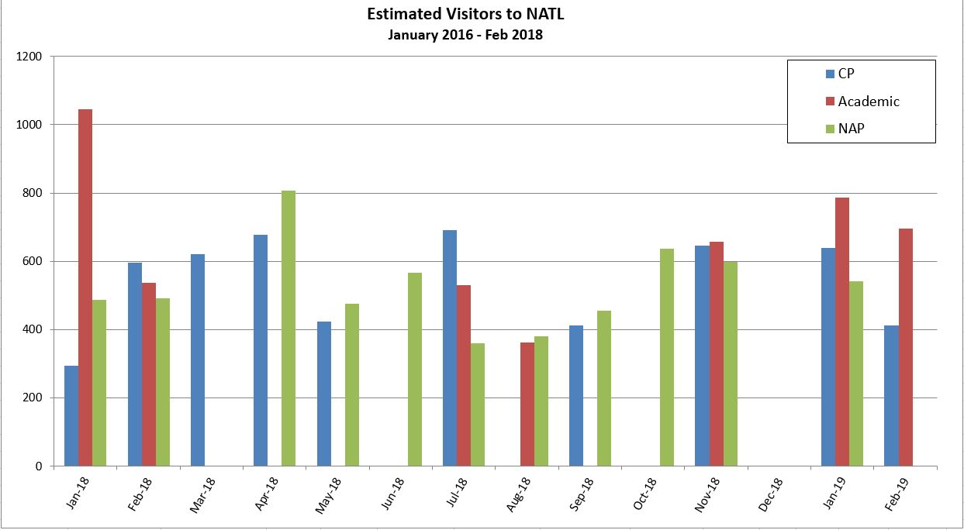
Figure 2. Summary of TrailMaster counts from January 2018 to February 2019 at the Cultural Plaza, Academic and NAP entrances. All numbers are TrailMaster counts/2 because users are counted twice, as they enter and exit.

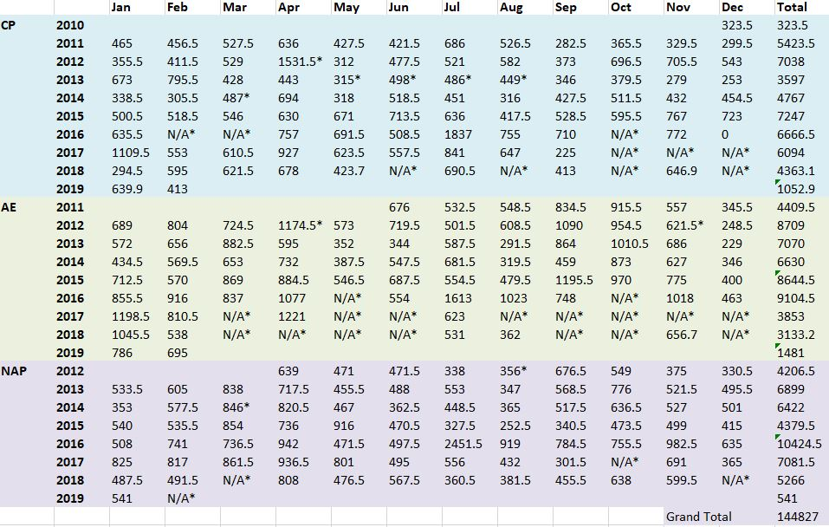
Table 1. Summary of NATL usage estimates via TrailMaster counts. All numbers are TrailMaster counts/2 because users are counted twice, as they enter and exit.
*Technical difficulties

Volunteer summary
NATL took part in the Fall Day of Service on October 20th. This involved a large group of students helping to trim trails and pick up trash. We also participated and represented NATL in the following events: The Butterfly Festival on October 13th, The Fall Organization Fair on September 19th, and the Educator Open House Event on October 4th. The Big Event was held on March 16th and included students from the Freshmen Leadership Council (Figure 3). They helped to clean NATL East and South Trail of trash.
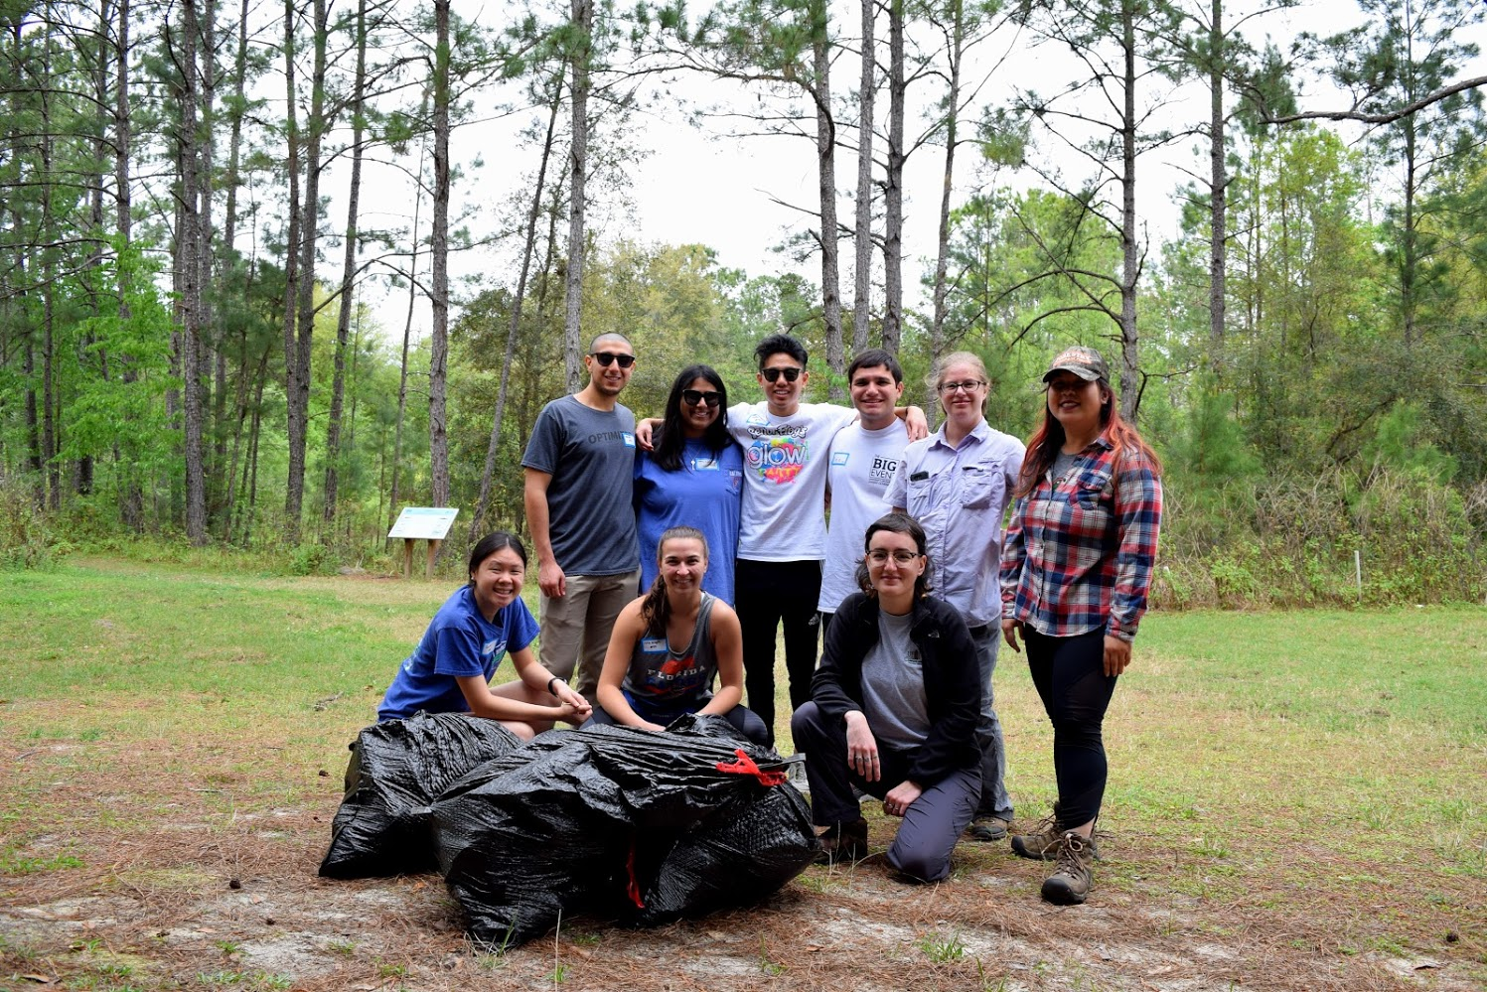

Figure 3. The volunteers from the Freshmen Leadership Council and staff members Jessica Hong, Jennifer Eells and Erika Brownson cleaned up trash at theBig Event on March 16th.

On March 21st, the Florida Museum of Natural History held a BioBlitz for Adania Flemming’s LDC2019 class and visiting educators at NATL. Graduate and Undergraduate TAs Jennifer Eells and Erika Brownson participated in the event which included surveys of insects, plants, amphibians, and aquatic flora and fauna. The students were divided into groups based on taxa (plants, birds, mammals, aquatic vertebrates and invertebrates) and either collected (Figure 5), took photos or spotted the different organisms. All species captured were photographed and listed on the board at the pavilion (Figure 4) as well as on the nature app iNaturalist.

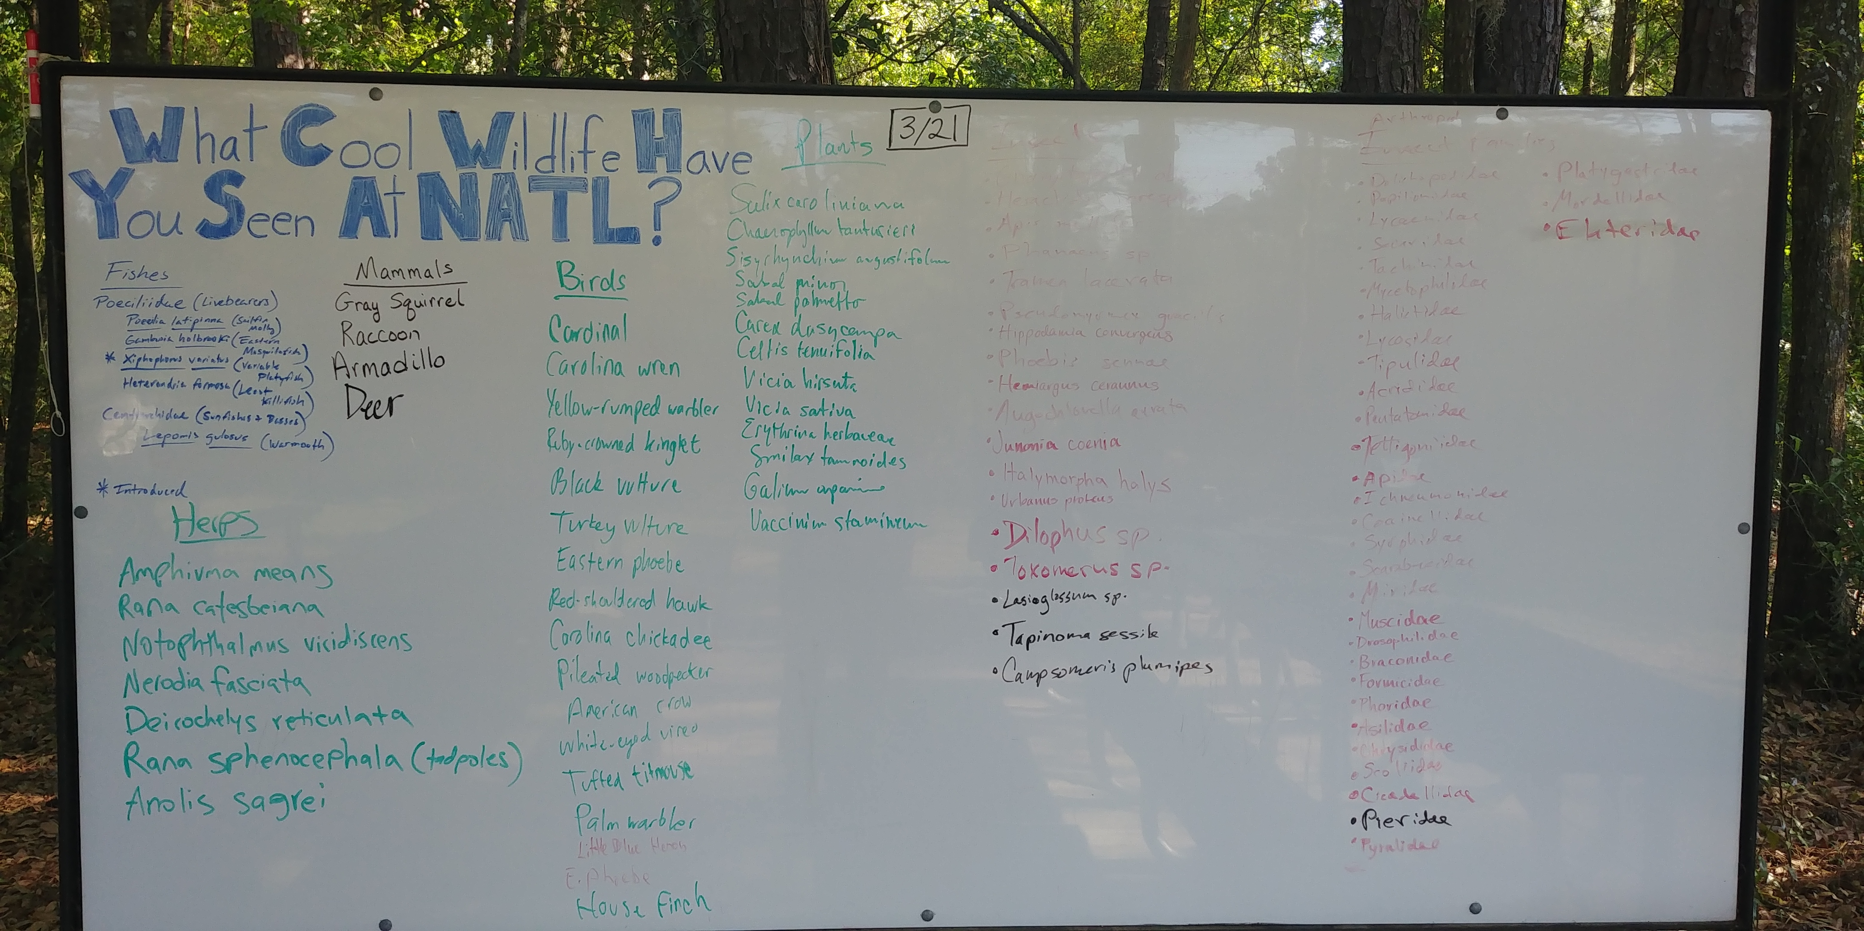
Figure 4. The whiteboard at NATL with the lists of all the species discovered during the BioBlitz on March 21st. There were categories for plants, birds, mammals, insects (aquatic and terrestrial), amphibians and reptiles.

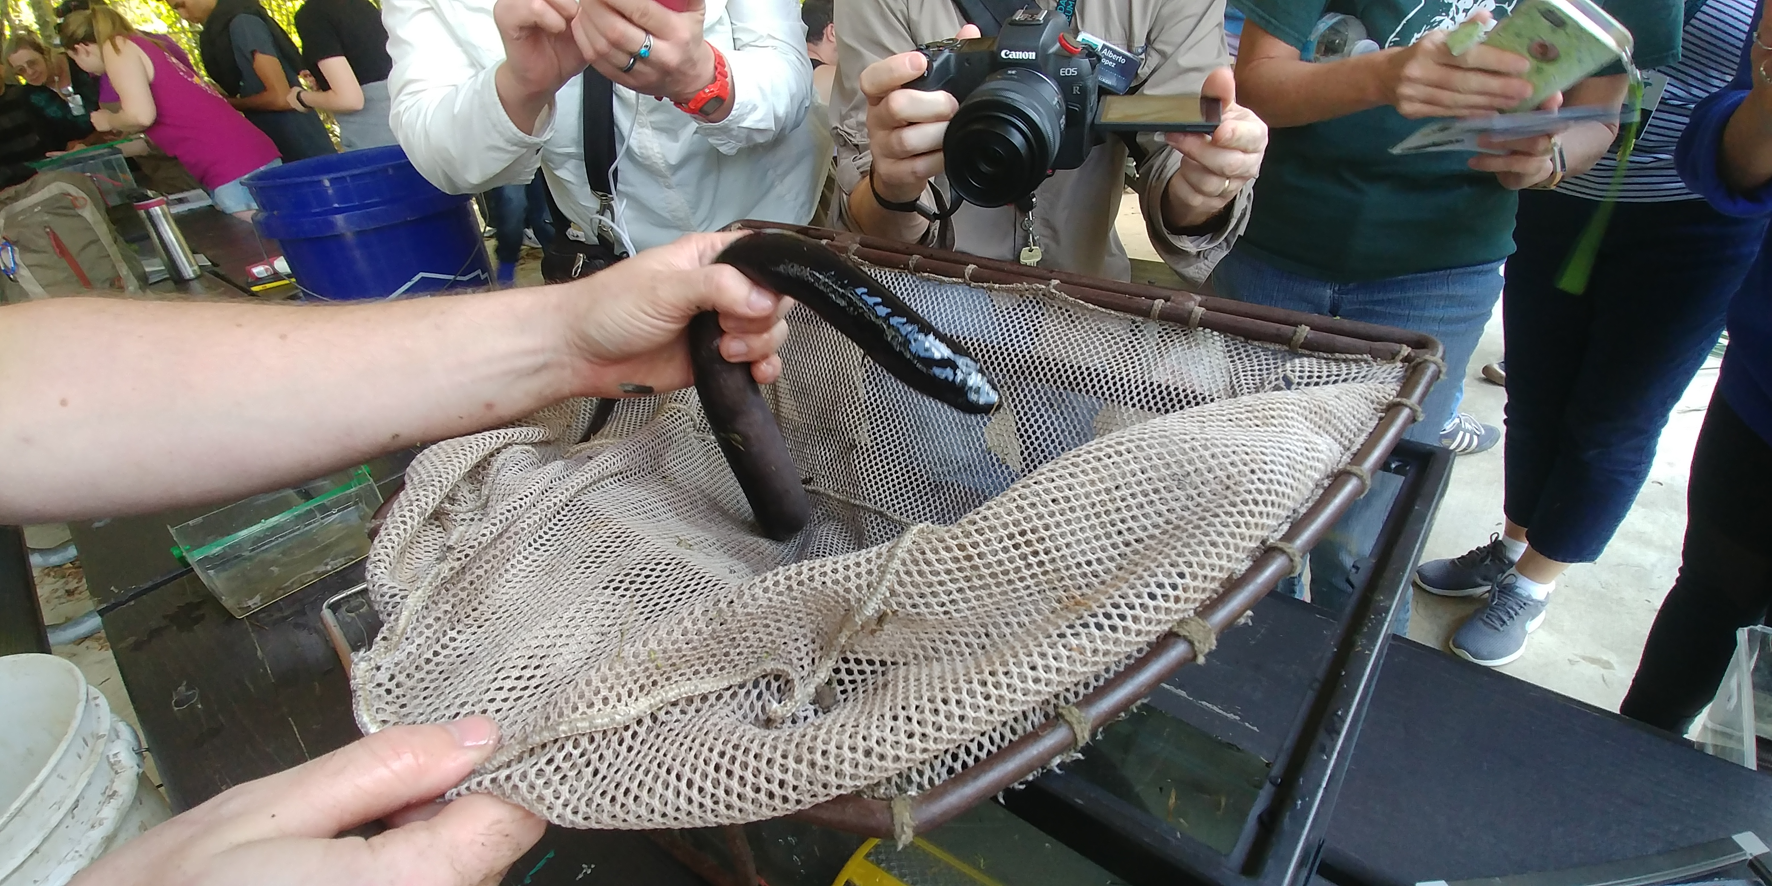

Figure 5. A two-toed amphiuma (Amphiuma means) was found in NATL East during the Bioblitz and was a big hit with the participants.

Mini-grant Update
Two of the 2017-2018 mini-grants are still in progress and one was completed. A short description and update on the current projects are as follows:
Avian Species Richness Surveys and Checklists (2018) - The PI for the project is Zachary Holmes, the president of the student group GREBE and a student in the Department of Wildlife Ecology and Conservation. His academic advisor is Dr. Katie Sieving. The group has conducted avian point count surveys and evaluated which species use NATL throughout the year. From these surveys, they have updated the website and are working with NATL staff to make improvements to the Biota page. GREBE has revised and updated the SEEP bird sign. They are currently working on the website, their report and bird checklists to be placed in NATL so visitors can learn what species of birds they observe and if they are permanent or temporary residents.
Non-Crop hosts of agriculturally important organisms in the Natural Area Teaching Lab (2018) – The PI is Cory Penca, a dual enrolled DPM/PhD student in the Entomology and Nematology Department, representing the Doctor of Plant Medicine Student Organization. Their academic advisor is Dr. Amanda Hodges also in the Department of Entomology and Nematology. . The project surveyed NATL for insects, nematodes, fungi and plant pathogens known to impact agricultural systems. They have prepared a draft fact sheet, available for digital and print use that highlights the interaction between natural areas and these organisms, with specific interest paid to the ecological role of non-crop plant species in supporting populations of agriculturally significant organisms. The group is now preparing its report.
Due to a lack of candidates applying for the mini-grants we decided to evolve the program into a NATL improvement project internship. This would be available for one participant that wanted to conduct a NATL improvement project. We have two applicants and will make a decision shortly.

Personnel Changes
Ashley Morris was hired as the new Invasive Species Intern on February 25th, 2018. Ashley is an undergraduate student in Entomology and Nematology with a specialization in biosecurity. Before coming to NATL, she worked for the UF Urban Entomology Lab and volunteered for the Forest Service. She will be replacing the outgoing intern, Alexandra (Lexie) Nielsen.

Social Media Updates
NATL’s Facebook page has 1,317 Likes and our Twitter page has 1,622 Followers. Since the last NAAC meeting in September, we have increased our Facebook Likes and gained 77 followers on Twitter! The NATL Instagram account, created in June 2015, has 683 Followers, 131 more than the number of followers at the Fall 2018 NAAC meeting.
If you use social media, please follow NATL on Facebook, Twitter, and Instagram. The NATL Operations Committee makes an effort to post several times a week about what is going on in NATL. We also love posting about visitors using NATL, so please share any pictures or observations with us on any of these social media accounts.

Status of Control of Invasive Plants in NATL
Guinea grass is still a major invasive, with patches growing through the upland pine and old field areas. In April, a grass walk with Mike Drummond from the Alachua County Environmental Protection Department was conducted to determine the various species of grasses in NATL, with guinea grass being the most widespread. Guinea grass regrowth (after being treated with glyphosate) during the summer was rapid but has begun to slow down recently. This will make it easier to manage patches of the grass and prevent new patches from growing (Figure 6). Mimosa has been much less common than it has in previous years, with only 13 plants treated so far this year compared to 534 treated in 2017.

Top FLEPPC category 1 plants in NATL include cogon grass (Imperata cylindrica), coral ardisia (Ardisia crenata), cat's claw vine (Macfadyena unguis-cati), air potato (Dioscorea bulbifera), skunk vine (Paederia foetida), and Japanese climbing fern (Lygodium japonicum). Category 2 plants include but are not limited to paper mulberry (Broussonetia papyrifera), silverthorn (Elaeagnus pungens), and Chinaberry tree (Melia azedarach). More information about invasive plant management in NATL can be found on the NATL website (http://natl.ifas.ufl.edu/biota/invasive_control.php).

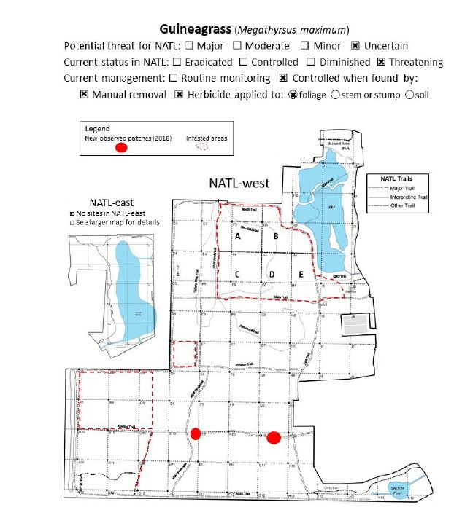

Figure 6. A 2018 map of guinea grass infestation in NATL. Since 2011 it has spread to other upland pine areas as well as two patches along Gasline Trail, which is a hammock ecosystem.
Table 2. The top invasive species removed in NATL. The numbers indicate how many individual plants were managed. See Appendix 2 for a more in depth table with additional species.
Species name | Common name | 2015 | 2016 | 2017 | 2018 | 2019*
Albizia julibrissin | Mimosa | 168 | 168 | 496 | 15 | 0
Ardisia crenata | Coral ardisia | 1152 | 550 | 581 | 1164 | 25
Broussonetia papyrifera | Paper mulberry | 2 | 71 | 16 | 1 | 0
Cinnamomum camphora | Camphor tree | 4 | 801 | 69 | 13 | 0
Dioscorea bulbifera | Air potato | 0 | 4 | 24 vines | 2 | 1
Megathryus maximum/Sorghum halpense | Guinea/Johnson grass (# of times patches sprayed) | ND | 15 | 17 | 28 | 16
*Indicates the year is not over yet and thus, additional plant removal may be added in in the future.
Nature trail update
We maintain our trails to a height of 80 inches to be compliant with the Americans with Disabilities Act (ADA). The NATL TAs routinely trim the nature trails and roads. Each semester, we attempt to assemble volunteer groups to help trim and pick up trash. Each nature trail is mowed by the undergraduate TA biweekly and weekly in the summer months while all over trails are mowed by Facility Services. The signs on our self-guided nature trails are updated weekly and trail sequences via Excel spreadsheets are updated monthly to reflect any changes and to help facilitate future seasonal updating of the trails. All signs are routinely cleaned while new signs are put up for new species and non-relevant signs are pulled, while yellow flagging tape are refreshed on plants weekly. Any fallen tree or trail blockage will be lopped and/or chain sawed and removed. SEEP boardwalk is swept biweekly.
A massive reorganizing of the shed including an inventory and map of item locations is currently ongoing. The boardwalk has developed a large hole and another possible weak spot near it. Installation of new boards and a look at the integrity of the posts will constitute a quick fix option while the fate of a new boardwalk is ongoing.
Oldfield Update
There will be an Old-field restart of subplot B SW (1-year) in April of 2019 through double disking. Additionally, we hope to fulfill one of the original tenets of NATL and plant food crops for wildlife in the 1 year plots. The crop will consist of native Florida maize and help to feed and attract local wildlife. It will also be a better visual education to the status of abandoned agriculture fields in Florida. The Old-field trail will be mowed and maintained weekly by the undergraduate TA.
Restoration of Upland Pine
In spring 2016, members of the NATL staff outlined a demonstration area to contrast three upland pine restoration treatments: burning, mowing and herbicide. The demonstration area is situated on the western end of the restricted area (see Fig. 7). Half of an area, 50 meters wide by 200 meters long, was designated to demonstrate an herbicide treatment, and the other half of the area was designated to demonstrate a mowing treatment. In addition, another segment will be allotted to the combined treatments of herbicide + fire and mow + fire treatments. Our previous burn was in April 2018 and finished combination treatments by August 2018. NATL plans to burn in April-May of 2019. In 2019, in efforts to shift the plant species from ruderal to those more indicative of a longleaf pine ecosystem began. Seeds and seedlings from local nurseries will be reintroduced into the upland pine area.

Plant Surveys
NATL Permanent Annual Plant Diversity Inventory & Monitoring Project
Background and Rationale
Outside of photographs, NATL has had no monitoring of plant diversity or composition in its natural communities. Monitoring is extremely important because it can guide our decision-making concerning the impact our management actions have on certain ecotypes. A prime area of concern is the upland pine community, where active restoration and resources are being spent but no monitoring is occurring. Monitoring in the succession plots would also be beneficial because it has been observed over the years that certain species are becoming increasingly dominant in frequently tilled plots. It is postulated that the lack of ruderal diversity in some succession plots is being caused by a lack of ruderals in the seed bank which is due to long-term and repeated tilling. Management may need to rotate the successional plots to increase seed bank diversity which will help limit the increasing dominance of certain species. Issues such as these is why data on plant composition is needed to better support and guide management decisions at NATL. Overtime, monitoring data would also help inform visitors and provide real data for any potential undergraduate projects as well.
Implementation & Status
In 2018 members of the NATL operations committee, along with volunteers, helped establish a set of long-term monitoring plots. The plots established are 10m² and feature five nested quadrats of sizes (0.01m², 0.1m², 1m², 3.16m², 10m²). Areas at NATL are heterogeneous, it was thought this design would be best fit to properly understand and estimate the plant composition in each community. The plot design was also chosen because it would enable NATL to realistically and accurately sample communities with few personal on ground (as opposed to transect, or grid sampling). A total of 11 plots were established at NATL, 7 Upland Pine Sites and 4 in the Succession Plots. Plots were established with donated scrap metal poles, marked with GPS, and photographed from the south facing north. In each plot species presence were recorded only once as they occurred in each nested quadrat. Coverage for each species was measured at the 10m² level. The overstory was included but denoted with and the * symbol in the data. Implementation of the plots began in November of 2018 and ended in January of 2019 – going forward we would like to standardize and limit monitoring to October – November months entirely. The 2018 data and map of plots is available and will begin to be analyzed after next years (2019) monitoring. Transferring this information to NATL’s website is currently in process.

Figure 7. Map showing demo plots.

Appendix 1. NAAC roster Spring 2019
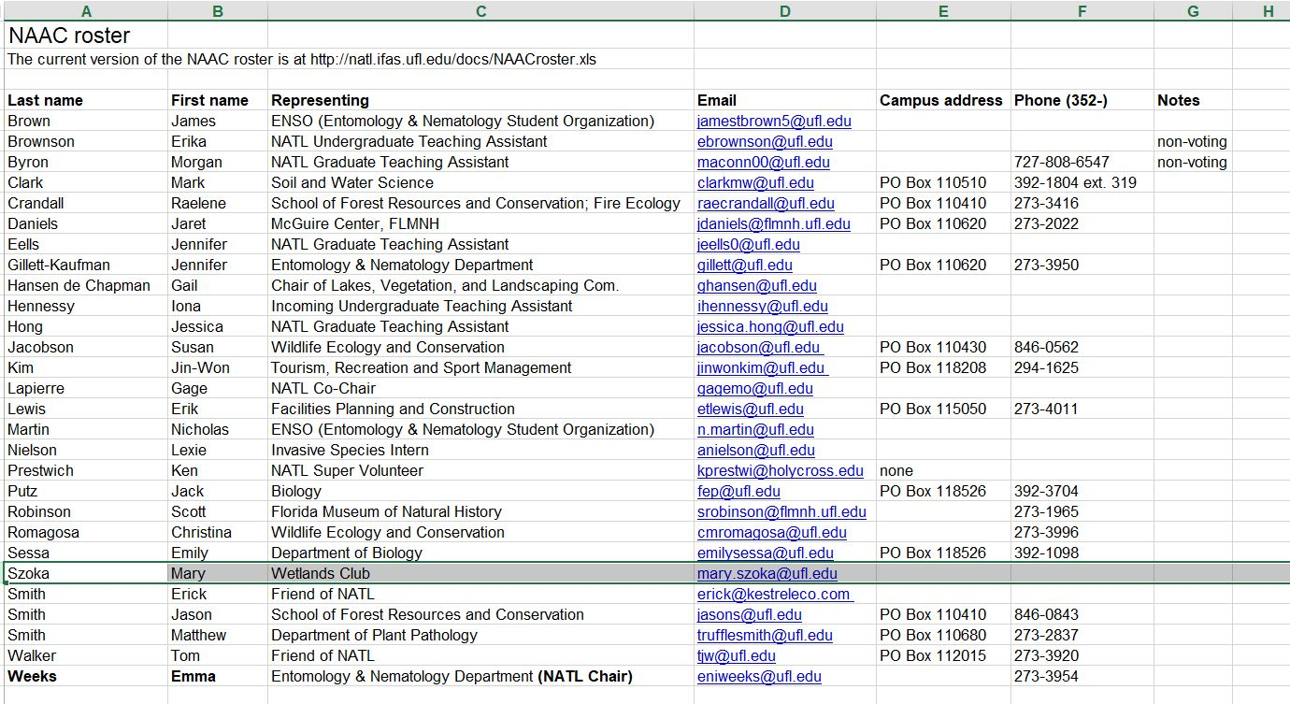

Appendix 2. Status of Control of Invasive Plants in NATL
The table below is a summary of some of the top invasive species removed in NATL. The numbers indicate how many individual plants were managed in each year.
