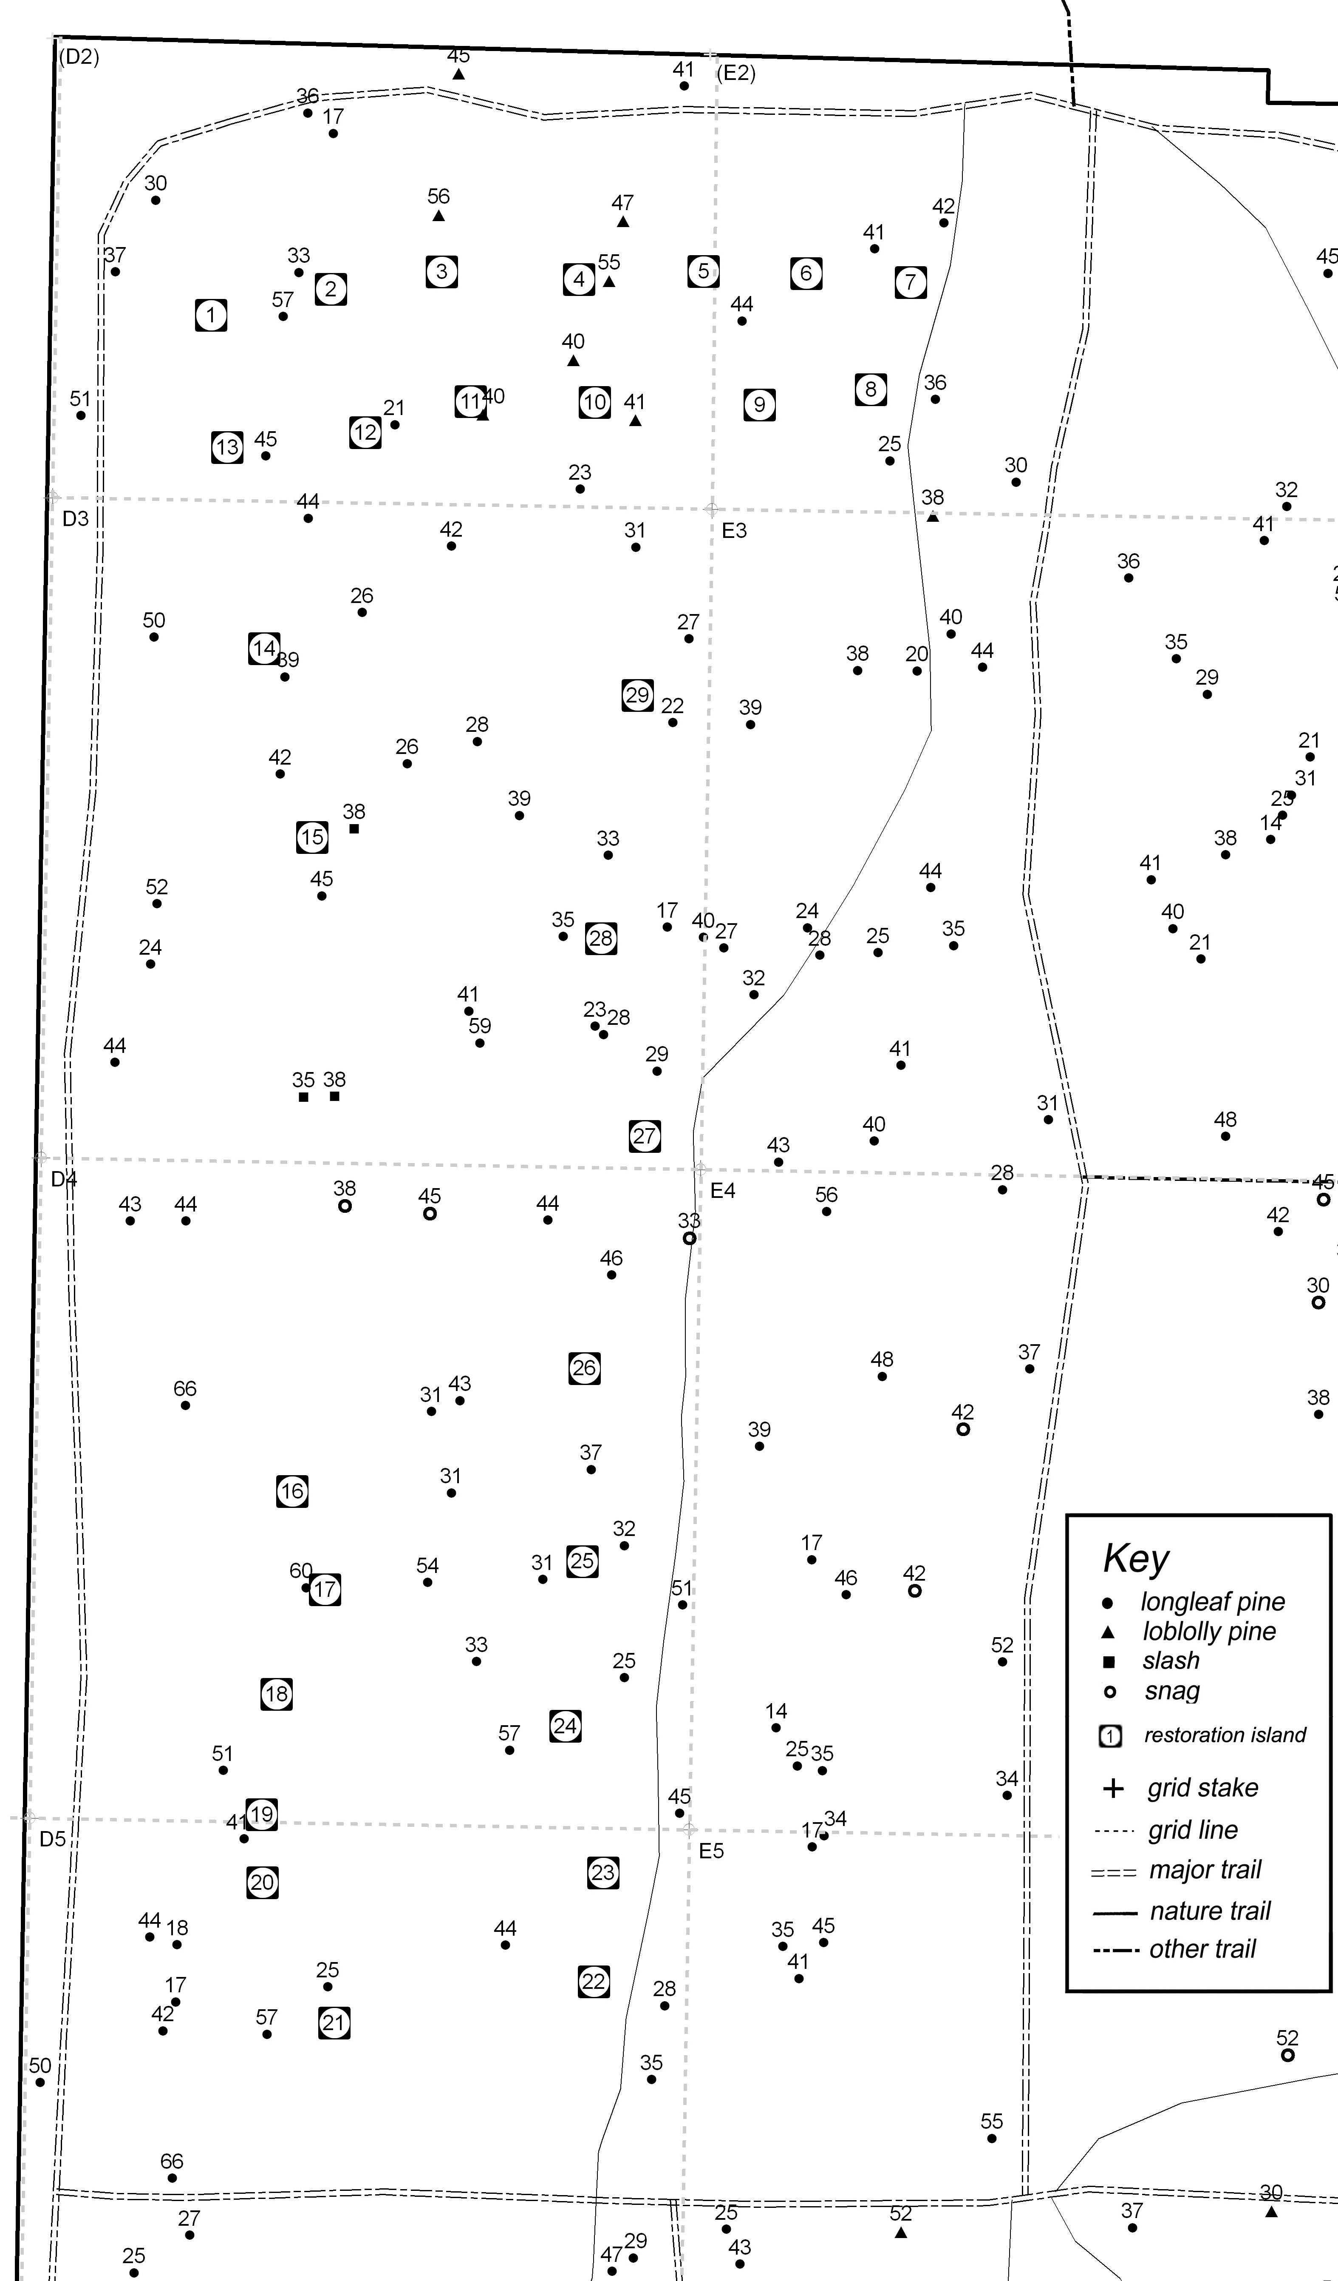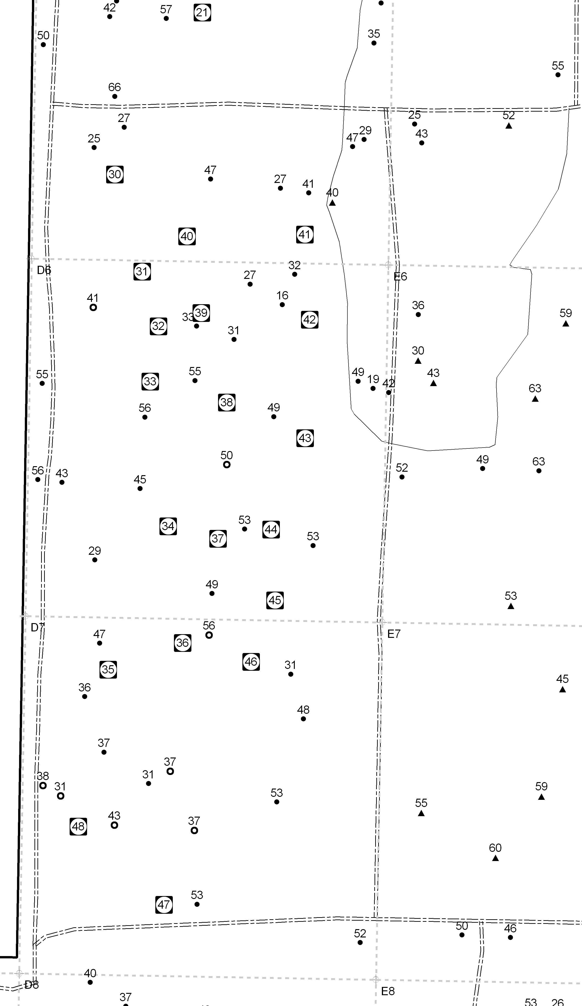
The unexplained, rapid disappearance of more than 90% of 248 small, nursery-grown longleaf pines planted haphazardly in the public area upland pine in 2003 led to the use of restoration islands for planting 288 similar pines in 2005. Each island was a cleared area 4 to 5 m in diameter in which six pines and 18 wiregrass slips were planted. This permitted easy monitoring, and intervening when potential mortality agents were recognized.
The numbers adjacent to the trees in the two maps at right are the diameters at breast high (DBH), as measured in cm in 2008.

Details of the growth and survival of the 288 pines planted in the islands are in most of the spreadsheets in the workbook at
http://natl.ifas.ufl.edu/smlpines05.xls
Maps of the pines without restoration islands are at
http://natl.ifas.ufl.edu/Pinemaps.htm

M

